

**الجمهورية اليمنية**

**وزارة التعليم العالي والبحث العلمي**

**جامعة تعز**

**كلية السعيد للهندسة و تكنولوجيا المعلومات**

**قسم هندسة البرمجيات**

**Republic of Yemen**

**Ministry of Higher Education and Scientific Research**

**Taiz University**

**Al-Saeed Faculty of Engineering and IT**

**Software Engineering Department**

AI-Driven Blockchain Platform for

Enhanced Patient Records

Management

Submitted By:

Osama Abdulwahed Abdo Noman Alathwari

Mohammed Ali Abdo Muthanna

Ahmed Abdulhameed Abdulazeez qahtan

Abdulrahman Hamood Mohammed Saeed

Mohammed Abdulazeez Qasem Mohammed

Supervised by:

DR. AHMED ALSHAMERI

Yemen-Taiz

2023-2024

Table of Contents

***1.*** ***Chapter 1: Introduction*** 1

**1.1.** **Introduction** 2

**1.2.** **Problem Statement** 3

**1.3.** **Existing System and its Problems** 3

**1.4.** **Proposed System** 5

**1.5.** **Project Motivation** 7

**1.6.** **Project goals** 8

**1.7.** **Project Objectives** 8

**1.7.1.** **General Objectives** 8

**1.7.2.** **Specific Objectives** 9

**1.8.** **Project Scope** 10

**1.9.** **Methodology** 12

**1.10.** **Targeted Customers and Beneficiaries** 12

**1.11.** **Project Structure** 13

***2.*** ***Chapter 2: Literature Review and Background*** 14

**2.1.** **Traditional Healthcare** 15

**2.2.** **Electronic Healthcare** 16

**2.3.** **Importance of Healthcare** 18

**2.4.** **Traditional Healthcare Records** 21

**2.5.** **Electronic Healthcare Records** 24

**2.6.** **Traditional Healthcare Records VS Electronic Healthcare Records** 25

**2.7.** **Importance of Electronic Healthcare Records** 29

**2.8.** **WEB2 VS WEB3** 31

**2.9.** **WEB3 BENEFITS** 31

**3.1.** **WEB3 LIMITATIONS** 32

**3.2.** **CENTRALIZATION VS DECENTRALIZATION** 32

**3.3.** **Blockchain** 33

**3.4.** **Blockchain Platforms** 40

**3.4.1.** **Ethereum Platform** 40

**3.4.2.** **IBM Blockchain Platform** 41

**3.4.3.** **Hyperledger Platform** 42

**3.4.4.** **Hydrachain Platform** 42

**3.4.5.** **R3 Corda Platform** 43

**3.4.6.** **Multichain Platform** 44

**3.4.7.** **BigchainDB Platform** 44

**3.4.8.** **Openchain Platform** 45

**3.4.9.** **Quorum Blockchain Platform** 45

**3.4.10.** **EOS Blockchain Platform** 46

**3.4.11.** **Other Blockchain Platforms** 46

**3.5.** **Blockchain in Healthcare** 46

**3.6.** **AI** 48

**3.7.** **Importance of AI in Healthcare** 50

**3.8.** **Importance of AI in Patients Record Management System** 52

**3.9.** **Internet Technology** 53

**3.10.** **Web Programing Languages** 54

**3.11.** **Single Page compared to Multi-Page Application** 54

**3.12.** **Front-End Programing Languages** 55

**3.12.1.** **Hypertext Markup Language HTML** 56

**3.12.2.** **Cascade Style Sheeting CSS** 56

**3.12.3.** **JavaScript** 57

**3.13.** **Frontend Frameworks and Libraries** 57

**3.13.1.** **ReactJS** 57

**3.13.2.** **Angular** 58

**3.13.3.** **Vue.JS** 59

**3.14.** **Back-End Frameworks and Languages** 60

**3.14.1.** **NodeJS** 60

**3.14.2.** **Laravel** 61

**3.14.3.** **Django** 61

**3.14.4.** **Personal Home Page PHP** 62

**3.15.** **GitHub** 62

**3.16.** **PostgreSQL** 63

**3.17.** **IPFS** 65

**3.18.** **Python** 68

**3.19.** **Visual Studio Code** 70

**3.20.** **Smart Contracts** 70

**3.21.** **Conclusion** 70

# ***Chapter 1: Introduction***

***Chapter 1: Introduction***

## **Introduction**

In the ever-evolving landscape of healthcare, the need for a robust and efficient system to manage patient records has never been more crucial. Recognizing the limitations and vulnerabilities of conventional approaches, our project embarks on a groundbreaking journey to revolutionize healthcare record management through the fusion of artificial intelligence and blockchain technology.

Imagine a future where patient records are not just securely stored but are intelligently managed, ensuring accessibility, security, and seamless interoperability. Our vision is to bring this future into reality by developing an innovative AI-driven blockchain platform that redefines the way healthcare records are handled

Traditional healthcare record systems have long struggled with issues such as data security breaches, lack of accessibility, and the inherent challenge of ensuring smooth communication and coordination between different entities in the healthcare ecosystem. Our project seeks to address these challenges head-on, presenting a paradigm shift in the way patient records are managed.

The integration of artificial intelligence and blockchain technology forms the backbone of our solution. Artificial intelligence will empower the platform to intelligently analyze and interpret vast amounts of patient data, offering valuable insights for personalized healthcare. Meanwhile, the inherent security features of blockchain will ensure the confidentiality and integrity of these records, mitigating the risks associated with unauthorized access or data tampering.

This platform not only promises enhanced security but also emphasizes accessibility, ensuring that authorized stakeholders have timely and convenient access to patient records when needed. Moreover, the interoperability aspect will facilitate seamless communication and data exchange between different healthcare providers, fostering a more connected and collaborative healthcare ecosystem.

As we embark on this ambitious venture, our mission is clear: to reshape the landscape of healthcare record management, placing the power of advanced technologies at the service of both healthcare professionals and patients. Join us on this journey as we pioneer a new era in healthcare, where data is not just secured but utilized intelligently to improve patient outcomes and transform the way we experience healthcare.

## **Problem Statement**

In the healthcare industry, managing patient records efficiently and securely is critical for providing high-quality care and ensuring patient privacy. However, existing systems often face challenges such as data fragmentation, security vulnerabilities, and lack of interoperability.

The current patient records management systems are fragmented across multiple healthcare providers, leading to inefficiencies in accessing and sharing patient information, or written on traditional paper system which leads to either those papers to get lost by patients themselves or mixing them up with other irrelevant papers.

Moreover, traditional databases are susceptible to security breaches, compromising patient confidentiality. There is also a lack of interoperability between different healthcare systems, hindering seamless information exchange.

## **Existing System and its Problems**

The existing patient records management system operates on traditional paper-based methods, involving manual recording and storage of patient information in physical files. Administrative staff are responsible for inputting, organizing, retrieving, and updating patient records, which are stored in filing cabinets within healthcare facilities. Patient information, including personal details, medical history, test results, diagnoses, and treatment plans, is collected and documented on paper forms during registration or appointments. Each patient visit or encounter results in the creation of a new paper record, with subsequent updates made manually. However, this system functions independently of digital technologies and lacks integration with electronic health record (EHR) systems or other digital platforms, necessitating physical transfer of records between healthcare providers or departments. Performance is hindered by manual data entry and retrieval processes, leading to potential errors, longer wait times, and scalability limitations due to physical storage constraints. Moreover, security concerns arise from the vulnerability of paper records to loss, theft, or damage, with limited control over access and viewing privileges. Maintenance involves regular upkeep of filing systems and support for staff training on record-keeping procedures, but transitioning to a digital system could offer significant improvements in efficiency, accessibility, and security for patient record management.

There are some problems associated with the existing paper-based patient records management system, including:

* **Limited Accessibility and Inefficiency:** With patient records stored in physical files within filing cabinets, healthcare providers often face delays in accessing vital information. In emergency situations, where every second counts, this can have critical consequences for patient care. Moreover, the manual retrieval process consumes valuable time that could otherwise be spent attending to patients, leading to inefficiencies and potentially impacting overall healthcare quality.
* **Data Redundancy and Errors:** The reliance on paper records increases the likelihood of data redundancy and inconsistencies within patient files. Duplicate entries, missing information, or outdated records can all contribute to errors in diagnosis, treatment, and medication management. Such inaccuracies not only compromise patient safety but also pose legal and regulatory risks for healthcare providers.
* **Security and Privacy Concerns:** Paper-based records are inherently vulnerable to loss, theft, or unauthorized access. Unlike digital records, which can be encrypted and protected with robust cybersecurity measures, physical files lack adequate safeguards to ensure patient confidentiality. Breaches in security can lead to breaches in privacy, eroding patient trust and exposing healthcare organizations to legal liabilities.
* **Interoperability Challenges:** The lack of standardized formats and protocols for sharing patient information across different healthcare settings complicates care coordination and continuity. In today's interconnected healthcare landscape, where patients may receive treatment from multiple providers and institutions, seamless data exchange is essential for delivering comprehensive and integrated care. The absence of interoperability hampers communication between healthcare professionals, leading to fragmented care and potential gaps in treatment.
* **Inefficiency and Time-Consuming:** Retrieving patient records from physical files is a time-consuming process, impacting the efficiency of healthcare professionals and contributing to delays in patient care.
* **Financial Implications:** Maintaining paper-based records incurs substantial costs associated with storage, maintenance, and administrative overhead. Healthcare organizations must allocate resources to physical storage facilities, as well as personnel responsible for organizing and managing paper files. Over time, these expenses can accumulate, diverting funds away from frontline healthcare services and technological advancements that could enhance patient care.

In summary, the existing paper-based patient records management system presents a myriad of challenges that extend beyond mere inefficiencies in record-keeping. From compromised accessibility and security to interoperability barriers and financial burdens, these issues underscore the urgent need for healthcare organizations to transition towards modern, electronic health records (EHR) systems. By embracing digital solutions, healthcare providers can streamline workflows, improve data accuracy, enhance patient safety, and ultimately, elevate the standard of care delivered to patients.

## **Proposed System**

The proposed AI-Driven Blockchain Platform represents a revolutionary solution aimed at transforming the landscape of patient records management in healthcare. By leveraging the synergies of Artificial Intelligence (AI) and blockchain technology, the platform offers a comprehensive and secure ecosystem for storing, accessing, and analyzing patient data.

**Key Components:**

The platform consists of several key components, each contributing to its functionality and efficacy:

* **Blockchain Infrastructure:** At its core, the platform utilizes a decentralized blockchain infrastructure to ensure data integrity, security, and immutability. Transactions related to patient records are cryptographically linked and stored across a distributed network of nodes, eliminating the risk of tampering or unauthorized access.
* **Smart Contracts:** Smart contracts, deployed on the blockchain, govern the rules and logic of data access and sharing. These self-executing contracts automate processes such as consent management, data sharing agreements, and access controls, ensuring compliance with privacy regulations and patient preferences.
* **Artificial Intelligence (AI) Engine:** The AI engine embedded within the platform enables advanced data analytics and decision support functionalities. Machine learning algorithms analyze patient records, extracting insights, predicting outcomes, and providing personalized recommendations for healthcare professionals.
* **User Interface (UI) and Applications:** Intuitive user interfaces and applications provide healthcare professionals and patients with seamless access to the platform's features. These interfaces facilitate secure data entry, retrieval, and visualization, enhancing user experience and promoting adoption.

**Functionalities and Features:**

The AI-Driven Blockchain Platform offers a range of functionalities and features designed to address the diverse needs of healthcare stakeholders:

* **Secure Data Storage:** Patient records, encrypted and securely stored on the blockchain, remain accessible only to authorized users. The decentralized nature of the blockchain ensures resilience against data breaches and ensures data availability even in the event of network disruptions.
* **Interoperable Data Exchange:** The platform facilitates seamless and interoperable exchange of patient data between healthcare providers, laboratories, insurers, and other stakeholders. Smart contracts govern data sharing agreements, ensuring compliance with regulatory requirements and patient consent.
* **Advanced Analytics:** AI-driven analytics empower healthcare professionals with actionable insights derived from patient records. Predictive modelling, risk stratification, and population health management capabilities enable proactive interventions and personalized treatment plans.
* **Patient Empowerment:** Patients have greater control over their health data, with the ability to access, monitor, and contribute to their electronic health records. Transparent consent mechanisms allow patients to manage access permissions and track data usage.
* **Real-Time Decision Support:** AI-powered decision support tools assist healthcare professionals in making informed clinical decisions. Real-time alerts, diagnostic assistance, and treatment recommendations enhance the efficiency and effectiveness of patient care.

**Benefits and Advantages**

The proposed AI-Driven Blockchain Platform offers several benefits and advantages over traditional patient records management systems and even existing Electronic Health Care Systems (EHCS):

* **Enhanced Security and Privacy:** The decentralized and immutable nature of the blockchain ensures enhanced security and privacy of patient data, mitigating the risks associated with centralized systems.
* **Interoperability and Data Exchange:** The platform promotes interoperability and seamless data exchange between disparate healthcare systems, fostering collaboration and continuity of care.
* **Personalized Healthcare:** AI-driven analytics enable personalized medicine, tailoring treatments and interventions based on individual patient characteristics and medical history.
* **Efficiency and Cost Savings:** Automation of administrative tasks, coupled with advanced analytics, streamlines processes, reduces paperwork, and optimizes resource allocation, leading to improved efficiency and cost savings.

## **Project Motivation**

This project was created with the aim of addressing challenges commonly associated with traditional paper-based systems. The project seeks to tackle current gaps in these systems, which may include inefficiencies, delays, and difficulties in managing information. Additionally, ensuring the security of data is a key goal of the project. This involves protecting information from loss or damage and proposing the adoption of measures to preserve data integrity and provide it permanently. It also requires ensuring user privacy, which includes managing access control permissions and ensuring that users have appropriate and secure access to data while safeguarding sensitive information. In addition to the significant advancements in the field of artificial intelligence, this project aims to integrate these capabilities to enhance healthcare efficiency. This is achieved by accelerating data analysis and improving the precision of decision-making.

## **Project goals**

The main goal of this project is to design a web application that supports the properties of decentralized technology (Blockchain) and smart contracts using JavaScript and the React library. The project consists of a control panel and a user interface, aiming to manage patient records and store data in a decentralized manner, contributing to providing more privacy for the user. Additionally, the project seeks to reduce costs for healthcare centers and improve decision-making accuracy through the use of artificial intelligence techniques.

## **Project Objectives**

### **General Objectives**

The overarching goal of the project is to develop an AI-driven blockchain platform that revolutionizes the management of patient records within the healthcare industry. The primary focus of the project is to achieve the following objectives:

* 1. Secure and Decentralized Platform:
* Develop a secure and decentralized platform for the storage and management of patient records, leveraging the capabilities of blockchain technology.
* Utilize blockchain to ensure data integrity, transparency, and resistance to unauthorized tampering.
  1. Integration of AI Algorithms:
* Integrate advanced AI algorithms into the platform to analyze patient data comprehensively.
* Extract valuable insights from the data to enhance diagnostic accuracy and treatment effectiveness.
* Provide personalized healthcare recommendations based on AI-driven analysis.
  1. Robust Access Control Mechanism:
* Implement a robust access control mechanism to safeguard patient data privacy and confidentiality.
* Utilize blockchain-based smart contracts and cryptographic techniques to enforce stringent access controls.
  1. Facilitate Seamless Data Sharing:
* Establish mechanisms for seamless data sharing between healthcare providers.
* Enhance interoperability to promote effective coordination of care among different entities.

### **Specific Objectives**

To achieve the general objectives outlined above, the project will focus on specific, measurable outcomes:

1. Blockchain Implementation:

* Develop and deploy a secure and scalable blockchain infrastructure tailored for healthcare data.
* Implement smart contracts to automate and enforce access controls while maintaining patient privacy.

1. User Interface Design:

* Design an intuitive and user-friendly interface for healthcare professionals, ensuring efficient navigation and utilization.
* Create a patient portal with secure authentication mechanisms, empowering individuals to access and manage their health records.

1. AI Integration:

* Embed AI algorithms capable of in-depth analysis of patient records, identifying patterns, and generating valuable insights.
* Provide a user-friendly interface for healthcare professionals to interpret AI-generated insights for enhanced decision-making.

1. Access Control Implementation:

* Design and implement a robust access control mechanism using blockchain and cryptographic methods.
* Ensure that patient data access is strictly governed by predefined rules and permissions.

By successfully achieving these specific objectives, the project aims to revolutionize patient record management, establishing a secure, AI-driven blockchain platform that ensures privacy, facilitates data sharing, and enhances overall healthcare coordination.

## **Project Scope**

**The project will focus on developing a core platform (web + Mobile Application) powered with AI for users:**

**#Patients will be able to:**

1. Create a patient account on the platform securely and easily
2. Access and manage their own encrypted medical records
3. Sync their records across all devices
4. Add Emergency contacts for Emergency access Protocol
5. Schedule appointments with healthcare providers
6. Communicate securely with healthcare providers
7. View test results
8. Keep track of their medical records and doctor appointments
9. Get notified about their medicine time and their appointments
10. Authorize access to their data
11. Ability to provide feedback and report issues
12. Ability to pay their bills via several options {Bitcoin, Bank, Cash}
13. Ability to add their old paper records using only their phone camera with the power of AI implemented in the platform to convert to digital records

**#Doctors will be able to:**

1. Create a doctor account on the platform securely and easily
2. Review patient records
3. Update patient records
4. Prescribe Medications
5. Schedule appointments
6. Request tests
7. View test results
8. Communicate with patients securely
9. Collaborate with other healthcare providers
10. Summarize Entire Patient history using AI
11. Ability to make accurate diagnosis using AI

**#Pharmacies will be able to:**

1. Create a Pharmacy account on the platform securely and easily
2. Receive Electronic Perceptions
3. Dispense medications
4. Manage Inventory
5. Update patient medication records
6. Ability to get paid via several options {Bitcoin, Banks, cash}

**#****Laboratories will be able to:**

1. Create a Laboratory account on the platform securely and easily
2. Receive and process test orders from doctors or patients
3. Perform tests
4. Upload results to the system
5. Securely share results with doctors and patients
6. Communicate with doctors and patients securely
7. Ability to get paid via several options {Bitcoin, Banks, cash}

**#****X-Ray Section will be able to:**

1. Create an X-Ray Section account on the platform securely and easily
2. Schedule and perform imaging tests
3. Upload images and reports to the system
4. Securely share results with doctors and patients
5. Collaborate with doctors to interpret results
6. Communicate with doctors and patients securely
7. Ability to get paid via several options {Bitcoin, Banks, cash}

**#Hospitals and Clinics will be able to:**

1. Create a Hospital or clinic account on the platform securely and easily
2. Manage their doctors appointments
3. Ability to access patients records in critical or urgent situations
4. Ability to get paid via several options {Bitcoin, Banks, cash}

**#****Researchers and Public health authorities will be able to:**

1. **Researchers:** Access to a larger pool of di-identified data for clinical trials and other research purposes, leading to faster development of new treatments and theories
2. **Public Health Authorities:** Leverage the platform for disease surveillance and outbreak tracking and management

## **Methodology**

In this project we will use Hyperledger Fabric for Building the Blockchain Network, React Library to build the frontend, Node.js for backend development and writing Smart contracts also build dashboard by React and Node.js. The database we will use PostgreSQL and IPFS and Python for AI Integration

## **Targeted Customers and Beneficiaries**

***1. Patients:*** Users will have access to secure and accurate medical records and will be able to share these records with whom they want on the system

***2. Health Organizations:*** Users will have access to secure and accurate medical records with ability to update them and add new records

***3. Researchers and Public health authorities***: Users will have access to secure and accurate de-identified medical records just to read them without any ability to edit or update them

## **Project Structure**

**This report contains five chapters.**

**The first chapter:** Includes introduction, motives, objectives, scope, and Targeted Customers.

**The Second chapter:** discusses an introduction to the program, the date of implementation, techniques and languages used their in.

**The third chapter:** describes the analysis and design, defines the specifications and defines the functional and non-functional specifications and then the design and includes the plans for the project.

**The fourth Chapter:** reviews system implementation and evaluation and describes the project interfaces and how interfaces can be connected to the database, then he explains an overview of the system's testing and evaluation.

**The fifth chapter:** which includes the project accomplishments, the challenges and obstacles it has experienced, and then the future work that will be added to the project and its development.

# ***Chapter 2:*** ***Literature Review and Background***

***Chapter 2: Literature Review and Background***

## **Traditional Healthcare**

Traditional healthcare refers to the conventional methods of providing medical care and treatment that have been practiced for centuries. It encompasses a wide range of practices, including diagnosis, treatment, and prevention of illnesses, as well as the promotion of overall well-being. Traditional healthcare typically involves face-to-face interactions between patients and healthcare providers, such as doctors, nurses, and other medical professionals, in settings such as hospitals, clinics, and private practices.

Key features of traditional healthcare include physical consultations where patients visit healthcare facilities for in-person discussions about medical history, symptoms, and treatment options, often involving physical examinations and diagnostic tests. Patient records, including medical history, test results, diagnoses, and treatment plans, are often maintained manually using paper-based systems, leading to challenges related to storage, retrieval, and organization of information.

Traditional healthcare emphasizes direct interactions between patients and healthcare providers, allowing for personalized care and tailored treatment plans based on clinical judgment, medical knowledge, and established guidelines and protocols. However, access to traditional healthcare services may be limited by factors such as geographic location, socioeconomic status, and availability of healthcare providers and facilities. Additionally, traditional healthcare practices may be influenced by cultural beliefs, customs, and traditions, with healthcare providers often considering patients' cultural backgrounds and preferences when delivering care. Despite its historical dominance, traditional healthcare is evolving to meet the demands of modern healthcare systems, sometimes integrating with emerging approaches such as electronic healthcare.

Traditional healthcare faces several challenges in modern healthcare systems. One significant challenge is the reliance on manual record-keeping systems, which are often paper-based. This outdated method can result in inefficiencies in storing, retrieving, and organizing patient information, leading to potential errors and delays in healthcare delivery.

Furthermore, limited accessibility to traditional healthcare services is a prevalent issue, particularly in rural areas and underserved communities. Factors such as geographic location, socioeconomic status, and the availability of healthcare providers and facilities can pose barriers to accessing timely and quality healthcare.

Cultural influences also play a role in traditional healthcare practices, which can both enrich and complicate care delivery. Healthcare providers must navigate diverse cultural beliefs, customs, and traditions, while also ensuring that care is culturally sensitive and respectful of patients' backgrounds and preferences.

Moreover, the traditional model of face-to-face interactions between patients and healthcare providers may not always align with the evolving needs and preferences of patients, particularly in an increasingly digital world. Integrating new technologies and approaches, such as telemedicine and electronic health records, into traditional healthcare settings presents both opportunities and challenges in maintaining personalized care while embracing innovation.

Overall, while traditional healthcare has been foundational in addressing healthcare needs for centuries, it must adapt to meet the demands of modern healthcare systems, addressing challenges related to accessibility, record-keeping, cultural competency, and technological integration to ensure the delivery of high-quality, patient-centered care.

## **Electronic Healthcare**

E-Healthcare, or electronic healthcare, involves the integration of information technology and electronic communication into the healthcare industry with the goal of improving the efficiency, accessibility, and quality of healthcare services. This digital transformation encompasses a broad spectrum of technologies and applications designed to enhance the overall delivery of healthcare.

"E-health, use of digital technologies and telecommunications, such as computers, the Internet, and mobile devices, to facilitate health improvement and health care services. E-health is often used alongside traditional “off-line” (non-digital) approaches for the delivery of information directed to the patient and the health care consumer."[].

“To ensure quality patient care, the health care industry has been evolving a lot. While most of the developments may be in the discovery of various medicines and development of various tools for diagnosis and treatment, a swift transition to the digitization of patient information viz. complaint, test reports, diagnosis and prescriptions, etc. brought about a plethora of benefits to all stakeholders. Paper-based records had many disadvantages specifically their illegibility, storage and organization, information loss in case of disaster, lack of facilities to share data and many more."[].

Electronic Health Records (EHRs) replace traditional paper-based records, facilitating seamless data sharing among healthcare providers. Telemedicine and Telehealth leverage telecommunications technology for remote clinical services and health-related education, expanding healthcare access. Mobile Health (mHealth) integrates mobile devices and applications for health monitoring, while Remote Patient Monitoring (RPM) utilizes technology to track real-time health data, especially for managing chronic conditions. Health Information Exchange (HIE) ensures secure data sharing across healthcare entities, promoting better care coordination.

Big Data Analytics and Artificial Intelligence (AI) contribute to data-driven decision-making, enabling predictive analytics and personalized medicine. E-Prescribing streamlines medication management, and Patient Portals empower individuals to access their health information and communicate with providers securely. Cybersecurity measures remain critical in safeguarding patient data within this evolving digital landscape.

Digital tools give healthcare providers an extensive view of patient health by significantly increasing access to health data and giving patients greater control over their health. The result is increased efficiency and improved medical outcomes. In addition, Innovative IoT applications in healthcare continue to emerge, giving patients better insight into the health data and transmitting the health information to their physicians [].

There are several digital health technologies, for example, as shown in (Figure 2.1).

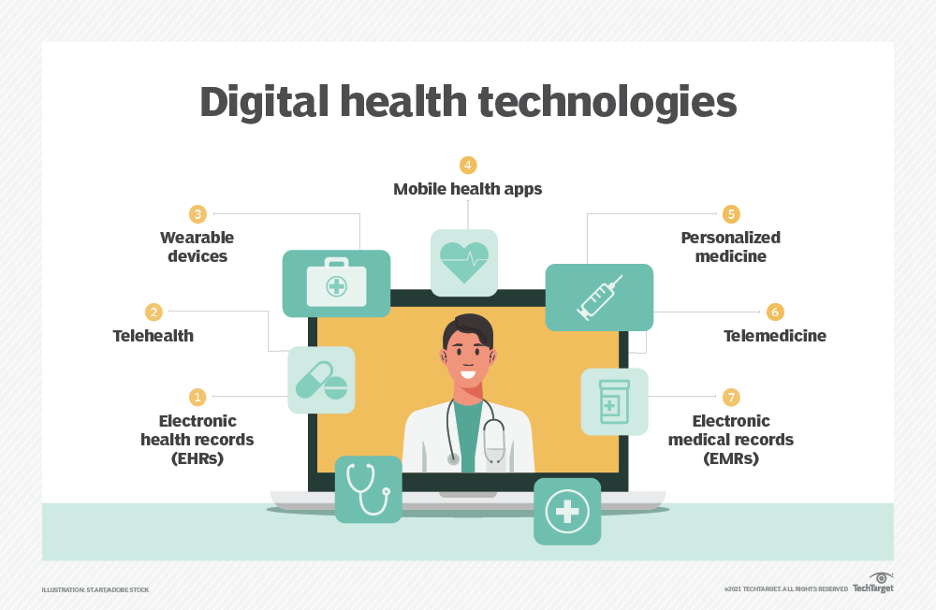

***Figure 2.1 Digital health technologies***

E-Healthcare integrates technology to enhance healthcare services, replacing paper-based records with EHRs, enabling telemedicine and remote monitoring, and employing AI for personalized care. These advancements improve efficiency, accessibility, and patient outcomes while ensuring data security. E-Healthcare represents a transformative shift in healthcare delivery.

## **Importance of Healthcare**

The importance of E-Healthcare lies in its potential to significantly enhance the efficiency, accessibility, and quality of healthcare services by leveraging digital technologies. Also, digital health technologies help providers reduce inefficiencies, improve access, reduce costs, increase quality and make medicine more personalized for patients. At the same time, digital health technologies enable patients and consumers to manage and track health and wellness-related activities more efficiently [].

Several key factors highlight the significance of E-Healthcare:

1. Improved Access to Healthcare: E-Healthcare breaks down geographical barriers, providing access to healthcare services remotely. Telemedicine, online consultations, and mobile health applications enable individuals to receive medical advice and consultations from the comfort of their homes. Also, “Technologies such as smartphones, social networks and internet applications offer new ways for patients to monitor their health and have increased access to information.” [].
2. Enhanced Efficiency and Coordination: Digital tools give healthcare providers an extensive view of patient health by significantly increasing access to health data and giving patients greater control over their health. The result is increased efficiency and improved medical outcomes."[]. For example, Electronic Health Records (EHRs) streamline the management of patient information, reducing paperwork and administrative burdens. This digitalization improves communication and coordination among healthcare providers, leading to more efficient and comprehensive patient care.
3. Real-time Monitoring and Management: E-Healthcare incorporates technologies such as Remote Patient Monitoring (RPM) and wearable devices, allowing healthcare professionals to monitor patients' health in real-time. This is especially crucial for managing chronic conditions and preventing health issues before they escalate.
4. Data-Driven Decision-Making: The use of big data analytics and artificial intelligence in E-Healthcare enables healthcare providers to analyze large datasets, extract meaningful insights, and make informed decisions. This data-driven approach contributes to personalized medicine, predictive analytics, and more effective treatment strategies.
5. Better quality care: Because less time is spent on (unnecessary) administration - think retyping data - hospital staff can focus on what really matters: delivering good care [].
6. Patient Empowerment: E-Healthcare empowers patients by providing them with access to their health information, enabling them to actively participate in their healthcare decisions. Patient portals, health apps, and online resources enhance health literacy and encourage proactive engagement in one's well-being.
7. Reduced Errors and Improved Safety: Electronic prescribing (E-Prescribing) reduces the likelihood of medication errors associated with handwritten prescriptions. Moreover, digital records minimize the risk of lost or misplaced patient information, contributing to overall patient safety.
8. More knowledge. Monitoring and analysis of questionnaires provide a lot of data. And more data leads to more knowledge and insight, which in turn leads to opportunities to improve the quality of care [].
9. Cost-Efficiency: While initial investments in E-Healthcare infrastructure may be substantial, the long-term benefits include cost savings through improved efficiency, reduced paperwork, and better management of resources. It can contribute to a more sustainable and cost-effective healthcare system.
10. Global Impact and Collaboration: E-Healthcare facilitates global collaboration among healthcare professionals, researchers, and organizations. Telemedicine and digital health platforms enable knowledge sharing and expertise exchange on a global scale, fostering innovation and best practices.
11. Public Health Surveillance: E-Healthcare plays a crucial role in public health surveillance by enabling the timely collection, analysis, and reporting of health data. This is particularly valuable in monitoring and responding to emerging health threats, such as infectious diseases or outbreaks.
12. Adaptability to Evolving Needs: The digital nature of E-Healthcare allows for continuous adaptation to evolving healthcare needs and technological advancements. This adaptability ensures that healthcare systems remain responsive to changing circumstances and can integrate new innovations seamlessly.

In summary, E-Healthcare is vital for creating a more accessible, efficient, and patient-centered healthcare ecosystem. By embracing digital technologies, healthcare providers can improve the overall quality of care, enhance patient outcomes, and contribute to the evolution of modern healthcare practices.

## **Traditional Healthcare Records**

Traditional healthcare records, also known as paper-based medical records, have long been the primary means of documenting patient information in the healthcare industry." Since time immemorial, hospitals and doctors have been giving handwritten or template-based prescriptions, test/scan reports and any such documents. These paper-based records were primarily used for clinical, research, financial and administrative purposes." []. These records encompass a wealth of data concerning an individual's medical history, treatments, diagnoses, and interactions with healthcare providers. They are comprised of physical documents such as charts, forms, and files meticulously arranged to provide a comprehensive overview of a patient's health journey.

At the heart of traditional healthcare records lies a section dedicated to patient demographics. Here, basic identifying information such as name, date of birth, gender, address, contact details, and insurance information is recorded, serving as the foundational identifier throughout the record. Following this, a detailed medical history is outlined, cataloging past illnesses, surgeries, medications, allergies, and family medical background. This section offers critical context for current health concerns and informs medical decision-making.

Clinical notes form another vital component of traditional healthcare records, serving as a narrative of the patient's medical encounters. These notes capture healthcare providers' observations, assessments, interventions, and progress over time. Additionally, diagnostic reports from various tests including blood work, imaging studies, and electrocardiograms are integrated into the records, providing objective data for diagnosis and treatment planning. Treatment plans, including prescribed medications, procedures, specialist referrals, and follow-up appointments, are meticulously documented to ensure continuity of care.

Regularly updated progress notes document the patient's response to treatment, changes in their condition, and adjustments to the care plan. Consent forms, authorizations for medical information release, and other legal documents ensure patients' rights are upheld and that they have provided informed consent for treatments. Furthermore, billing and insurance information, essential for managing healthcare finances and reimbursement, are included in these records. Legal documents such as advance directives and guardianship papers may also find their place, ensuring compliance with legal and ethical standards in healthcare practice.

Traditional healthcare records are meticulously organized and stored in physical filing systems within healthcare facilities. They are typically sorted alphabetically, by medical record number, or by date of service for ease of retrieval. While these records offer accessibility without relying on technology and are familiar to many healthcare professionals, they present challenges related to storage space, organization, and accessibility for authorized personnel. Nonetheless, traditional healthcare records remain a cornerstone of medical documentation, providing a tangible and comprehensive record of a patient's healthcare journey.

However, traditional healthcare records face several challenges and problems, including massive storage and difficult organization. With the increasing number of patients and the volume of information being recorded, it may become challenging to quickly find specific information. Additionally, “Paper-based records are difficult to maintain and store for years. Paper, in general, is prone to destruction or decay. Environmental factors like moisture may damage it. Rodents like mice or insects like termites may chew and waste them. As well as human error, like misplacement, deliberate destruction, etc. is another enemy of the long life of papers.” [].

Also, "Most of the handwritten prescriptions are illegible (see Figure 2.2 for a sample handwritten prescription). Even if a clinician uses a template, the handwritten fillings of the data are mostly illegible. While it appears prejudiced to say that doctors usually don’t have the best handwriting; maybe it’s due to paucity of time, or perhaps it’s just a matter of habit, but a doctor’s note is generally difficult to comprehend by people not belonging to the medical profession." [].

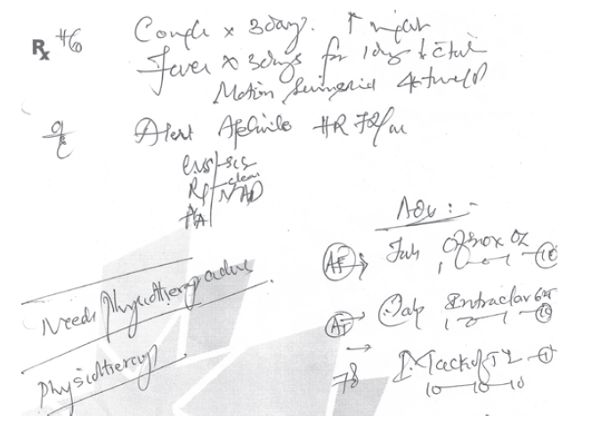

***Figure 2.2 A sample handwritten prescription***

Paper records are also vulnerable to unauthorized access, as anyone present in the medical facility can potentially access them, posing a threat to patient privacy and the security of their medical information. Furthermore, paper records may encounter challenges in sharing information among different healthcare providers, as they must be manually transferred between departments and different medical facilities.

Moreover, " Paper-based records are expensive to copy, share, store and transport." [], and traditional healthcare records can lead to delays in care delivery and medical decision-making, as manually searching for information can be time-consuming, negatively impacting the patient experience and the quality of care received. Additionally, it may be difficult to detect errors or changes in paper records due to the difficulty of making alterations without leaving a clear trace.

In this way, despite the many benefits offered by traditional healthcare records, they face multiple challenges that require innovative solutions to improve their efficiency and ensure the safety of patient information.

## **Electronic Healthcare Records**

An Electronic Health Record (EHR) functions as a digital repository, maintaining a comprehensive electronic version of a patient's medical history over time. This encompasses key administrative and clinical data relevant to the individual's care within a specific healthcare provider setting, including demographics, progress notes, problems, medications, vital signs, past medical history, immunizations, laboratory data, and radiology reports.

"An EHR is a digital version of a patient’s paper-based records of health. EHR is a patient-centric system, which makes data available instantaneously and securely to the official users in real-time. It does contain the medical histories of patients, also go beyond the clinical data collection and give a broader insight into a patient’s care. These electronic data items can be managed, transmitted, stored, reproduced, and replicated efficiently. With the incredible evolution of the acceptance of EMR, different clinical data such as diagnostic history, medications, lab test reports, demographics, vital sign, and so on are getting to be accessible. This sets up the EMR as a fortune gem for data analysis of health data." [].

The primary purpose of an EHR is to automate information access, streamlining clinician workflows, and improving the overall efficiency of healthcare delivery. By consolidating patient information into a centralized digital platform, EHRs facilitate seamless communication and coordination among healthcare providers, ensuring that pertinent data is readily accessible when making care-related decisions.

In addition to enhancing workflow efficiency, EHRs also support various care-related activities through interfaces such as evidence-based decision support, quality management, and outcomes reporting. These features enable healthcare providers to leverage data-driven insights and best practices, ultimately improving the quality and safety of patient care.

One of the significant benefits of EHR implementation is its role in reducing medical errors. By improving the accuracy and clarity of medical records, EHRs help mitigate potential errors stemming from illegible handwriting or incomplete documentation. This, in turn, enhances patient safety and reduces the risk of adverse events during treatment.

Moreover, "EHRs are used to share data with other health care organizations for instance specialists, pharmacies, medical imaging facilities, laboratories, emergency facilities, and providers for instance clinics. Hence the information is gathered from all clinicians to provide better health care to a patient. Information shared in these records should be protected by law and to the authorized users only" [].

Furthermore, embracing EHRs empowers patients to actively participate in their healthcare journey. Through secure patient portals and online access to their medical records, individuals can review their health information, track their progress, and communicate with their healthcare providers more effectively. This transparency fosters a stronger connection between patients and clinicians, promoting shared decision-making and personalized care.

Overall, the implementation of EHRs represents a pivotal measure in optimizing the overall healthcare landscape. By providing timely and accessible data, EHRs enable healthcare providers to make informed decisions, improve care coordination, and ultimately enhance the quality and efficiency of patient care delivery.

## **Traditional Healthcare Records VS Electronic Healthcare Records**

Traditional healthcare records, often paper-based, have been the primary means of documenting patient information for decades. They typically involve physical files stored in cabinets within healthcare facilities. On the other hand, e-healthcare records, also known as electronic health records (EHRs) or electronic medical records (EMRs), are digital versions of patients' medical histories.

The following table (Table 2.2**)** depicts a few of the vis-a-vis comparisons of EHR and paper-based records []:

***Table 2.1 Table depicting few of the vis-a-vis comparison of EHR and paper-based records***

|  |  |  |
| --- | --- | --- |
| **Features** | **EHR** | **Paper-based records** |
| Organization | Complete and systematic | Random |
| Sharing | Fast, efficient, economical | Cumbersome and costly |
| Accessibility | 24*7, parallel access | Limited, no parallel access |
| Search | Fast | Slow |
| Loss or misplacement of records | Rare | Frequent |
| Maintenance | Easy | Difficult |
| Illegibility | None | Might be |
| Analysis | Easy | Difficult |
| Security | High | Low |
| Environmental impact | Low | High |
| Impact of disaster | Low | High |
| Alerts, reminders | Yes | No |
| Compliance | Yes | May/may not |
| Archival | Indefinitely long | Paper shelf life |

The following is a comparison between the two types of healthcare records (Traditional and Electronic):

1. **Accessibility and Portability:**
   * Traditional Healthcare Records: Physical records are typically confined to the healthcare facility where they are stored. Accessing them remotely or sharing them with other healthcare providers often requires manual processes such as faxing or mailing copies.
   * E-Healthcare Records: Digital records can be accessed remotely from anywhere with an internet connection, enabling healthcare providers to view patient information quickly and easily. This facilitates seamless sharing of records between different healthcare settings, leading to improved coordination of care.
2. **Storage and Space:**
   * Traditional Healthcare Records: Paper-based records require physical storage space, including filing cabinets, rooms, and sometimes off-site storage facilities. As the volume of records grows over time, managing and storing them can become increasingly challenging.
   * E-Healthcare Records: Electronic records eliminate the need for physical storage space. Data is stored digitally on servers or in the cloud, which can be easily scaled to accommodate growing volumes of information. This not only saves physical space but also reduces the administrative burden associated with managing paper records.
3. **Data Security:**
   * Traditional Healthcare Records: Paper records are vulnerable to physical threats such as theft, damage from fire or water, and unauthorized access. Protecting the privacy and confidentiality of patient information can be challenging.
   * E-Healthcare Records: Digital records employ various security measures such as encryption, access controls, authentication mechanisms, and audit trails to safeguard patient data. While they are not immune to cybersecurity threats, e-healthcare records offer greater resilience against unauthorized access and breaches compared to paper-based systems.
4. **Efficiency and Workflow:**
   * Traditional Healthcare Records: Retrieving information from paper records can be time-consuming, requiring manual searches through files. Updating records also involves manual data entry, which can be prone to errors and duplication.
   * E-Healthcare Records: Digital records enable faster retrieval of information through electronic searches and indexing. Templates and prompts within electronic systems streamline documentation, reducing the time and effort required for data entry. Automated alerts and reminders can also improve workflow efficiency and facilitate timely interventions.
5. **Integration and Interoperability:**
   * Traditional Healthcare Records: Paper-based systems lack interoperability, making it difficult to exchange data between different healthcare providers and systems. This can lead to fragmented care and duplication of efforts.
   * E-Healthcare Records: Electronic records can be integrated with other healthcare systems, such as pharmacy systems, laboratory databases, and imaging systems, through standardized protocols and interfaces. This interoperability enables seamless exchange of information between healthcare providers, resulting in more coordinated and comprehensive care for patients.
6. **Cost:**
   * Traditional Healthcare Records: While the initial setup costs for paper-based systems may be lower, ongoing expenses accrue over time due to the need for physical storage, printing, and administrative overhead. Additionally, the costs associated with managing and maintaining paper records can increase as the volume of records grows.
   * E-Healthcare Records: Although the initial implementation costs of electronic systems may be higher due to investments in software, hardware, and training, e-healthcare records can lead to long-term cost savings. By improving efficiency, reducing reliance on paper-based processes, and minimizing errors, electronic systems can ultimately lower overall healthcare costs and improve resource utilization.

The following table (Table 2-2) summarizes the key differences between traditional healthcare records and e-healthcare records across various aspects:

**Table 2-2 comparison of traditional healthcare records and e-healthcare records**

|  |  |  |
| --- | --- | --- |
| **Aspect** | **Traditional Healthcare Records** | **E-Healthcare Records** |
| **Accessibility and Portability** | Limited to physical location, manual sharing | Accessible remotely, easier sharing between providers |
| **Storage and Space** | Require physical space, filing cabinets | Stored electronically, no physical space needed |
| **Data Security** | Vulnerable to physical damage, theft | Enhanced security measures, encryption, access controls |
| **Efficiency and Workflow** | Manual retrieval, updating can be labor-intensive | Faster retrieval, automated data entry, streamlined documentation |
| **Integration and Interoperability** | Lack interoperability, limited exchange between systems | Integration with other systems, seamless data sharing |
| **Cost** | Initial setup costs lower, ongoing expenses for storage, printing | Higher initial implementation costs, long-term savings |

In summary, e-healthcare records offer numerous advantages over traditional paper-based records, including improved accessibility, security, efficiency, interoperability, and cost-effectiveness. Transitioning from traditional records to electronic systems can enhance patient care delivery, streamline administrative processes, and support better clinical decision-making in healthcare settings.

## **Importance of Electronic Healthcare Records**

Electronic Health Records (EHRs) play a crucial role in modern healthcare systems, offering numerous benefits for both healthcare providers and patients. Here are some key reasons highlighting the importance of electronic health records:

1. Improved Accessibility and Efficiency: "Digital health records are one of the most reliable ways to get accurate patient information quickly." []. EHRs enable quick and easy access to patient information by authorized healthcare professionals, regardless of their physical location. This accessibility enhances the efficiency of healthcare delivery, allowing for faster decision-making and improved coordination of care.
2. Enhanced Patient Care and Safety: EHRs provide a comprehensive and up-to-date overview of a patient's medical history, medications, allergies, and test results. This information is vital for healthcare providers to make well-informed decisions, leading to better patient care and reduced medical errors.
3. Security and Privacy: "Enabling the security and privacy of patients medical information within multiple providers." [].
4. Coordination of Care: Electronic health records facilitate better communication and coordination among different healthcare providers involved in a patient's care. This is particularly important for patients with chronic conditions or those receiving care from multiple specialists.
5. Reduced Duplication of Tests and Procedures: EHRs help eliminate unnecessary duplication of tests and procedures by providing a centralized repository of patient information. This not only saves time and resources but also reduces the potential risks associated with repeated diagnostic tests.
6. Cost Savings: "Benefit organization in lower business-related costs" []. Over time, the implementation of EHRs can lead to cost savings for healthcare organizations. Electronic records reduce paperwork, streamline administrative processes, and contribute to more efficient use of resources.
7. Patient Engagement: EHRs empower patients to actively participate in their healthcare. Patients can access their records, view test results, and communicate with healthcare providers through secure online portals, fostering a more engaged and informed patient population.
8. Data Accuracy and Legibility: "Enhancing patient’s safety by reducing diagnostic errors and improving accuracy" []. EHRs eliminate the issues related to illegible handwriting seen in traditional paper records. Electronic records are typed and standardized, contributing to improved accuracy and reducing the likelihood of errors in documentation.
9. Compliance with Regulations: Many healthcare systems around the world have implemented regulations and standards that encourage or mandate the use of electronic health records. Meeting these regulatory requirements ensures that healthcare providers maintain high standards of care and data security.

In summary, electronic health records contribute significantly to the efficiency, safety, and overall quality of healthcare delivery. Their widespread adoption is a key component of the ongoing digital transformation in the healthcare industry.

## **WEB2 VS WEB3**

Web2 refers to the version of the internet most of us know today. An internet dominated by companies that provide services in exchange for your personal data. Web3 refers to decentralized apps that run on the blockchain. These are apps that allow anyone to participate without monetising their personal data.

## **WEB3 BENEFITS**

1. **Table 2- key differences between WEB2 and WEB3**

|  |  |
| --- | --- |
| Web2 | Web3 |
| Twitter can censor any account or tweet | Web3 tweets would be uncensorable because control is decentralized |
| Payment service may decide to not allow payments for certain types of work | Web3 payment apps require no personal data and can't prevent payments |
| Servers for gig-economy apps could go down and affect worker income | Web3 servers can't go down, they use a decentralized network of 1000s of computers as their backend |

## **WEB3 LIMITATIONS**

Web3 has some limitations right now:

* Scalability – transactions are slower on web3 because they're decentralized. Changes to state, like a payment, need to be processed by a node and propagated throughout the network.
* UX – interacting with web3 applications can require extra steps, software, and education. This can be a hurdle to adoption.
* Accessibility – the lack of integration in modern web browsers makes web3 less accessible to most users.
* Cost – most successful dapps put very small portions of their code on the blockchain as it's expensive.

## **CENTRALIZATION VS DECENTRALIZATION**

|  |  |
| --- | --- |
| Centralized Systems | Decentralized Systems |
| Low network diameter (all participants are connected to a central authority); information propagates quickly, as propagation is handled by a central authority with lots of computational resources. | The furthest participants on the network may potentially be many edges away from each other. Information broadcast from one side of the network may take a long time to reach the other side. |
| Usually higher performance (higher throughput, fewer total computational resources expended) and easier to implement. | Usually lower performance (lower throughput, more total computational resources expended) and more complex to implement. |
| In the event of conflicting data, resolution is clear and easy: the ultimate source of truth is the central authority. | A protocol (often complex) is needed for dispute resolution, if peers make conflicting claims about the state of data which participants are meant to be synchronized on. |
| Single point of failure: malicious actors may be able to take down the network by targeting the central authority. | No single point of failure: network can still function even if a large proportion of participants are attacked/taken out. |
| Coordination among network participants is much easier, and is handled by a central authority. Central authority can compel network participants to adopt upgrades, protocol updates, etc., with very little friction. | Coordination is often difficult, as no single agent has the final say in network-level decisions, protocol upgrades, etc. In the worst case, network is prone to fracturing when there are disagreements about protocol changes. |
| Central authority can censor data, potentially cutting off parts of the network from interacting with the rest of the network. | Censorship is much harder, as information has many ways to propagate across the network. |
| Participation in the network is controlled by the central authority. | Anyone can participate in the network; there are no “gatekeepers.” Ideally, the cost of participation is very low. |

## **Blockchain**

Blockchain is a collection of computers connected together in a peer-to-peer (P2P) network. It is a decentralized, distributed ledger system that records transactions across multiple computers in a way that ensures transparency, security, and immutability. It is the combination of existing technologies such as cryptography, shared ledger and distributed network. "Blockchain technology can be defined as a distributed system in which transactional or historical data can be recorded, stored and maintained across a network. It is a non-changeable, public digital ledger similar to a database. Blockchain technology is a horizontal innovation that can be adopted by any industry."[]. Blockchain 1.0 was announced as a bitcoin emergence in 2008; the chains of blocks which contain several units of information and transaction are which leverages the capabilities of digital ledger in an electronic P2P system. In 2013, Blockchain 2.0 introduced a public blockchain named Ethereum blockchain that facilitates a user to record the assets as smart contracts. It acts as a platform for developing many decentralized applications. In 2015, Hyperledger was introduced as an open-source blockchain that promotes global industry collaboration by improving the reliability and performance of current systems. Later, the blockchain networks involving private, public and federated (consortium) blockchains have started evolving in the recent years, which improves operational efficiency in blockchain technology applications. A transaction is represented by a user initiating a request to create a block and then the transaction being broadcasted for each node that is connected in the P2P network. Using consensus algorithms, all nodes validate each transaction along with the user details in the blockchain network. Once the transaction is validated, the block that is newly created can be added to the existing blockchain. The basic working procedure of blockchain is depicted in Figure

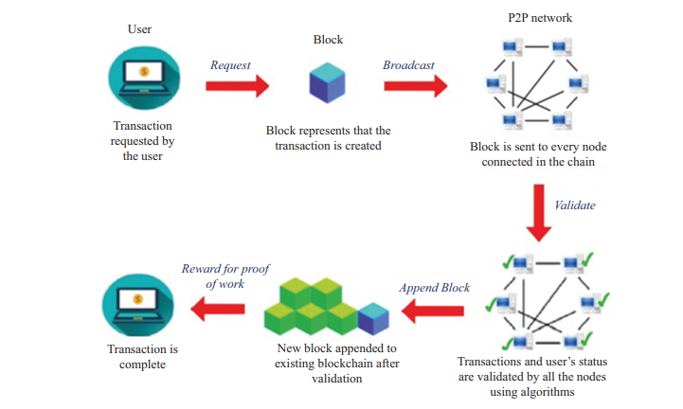

Blockchain technology has certain inherent features that can be utilized for diversified applications. The various characteristics include the following:

Decentralized: Public blockchain allows anyone connected to access, monitor, modify, and update the database without involving a central authority, reducing costs and performance issues. Consistency and integrity are maintained through consensus algorithms. In contrast, consortium and private blockchains vary in centralization, with the former being partially centralized and the latter fully centralized.

Transparency: Verification and tracking of data are easily achieved as all users on the network, i.e., the public, have access to the data. Interactions among nodes are verified by an authorized entity, ensuring automatic facilitation of transparency.

Persistence: "The transactions are distributed over all nodes that are validated and checked by other nodes using a consensus algorithm before it is being added to the block. Hence it is highly difficult to delete or alter any data. The public blockchain is immutable. However, if the majority of the nodes are interested in modifying the consortium and private blockchain, it can be altered".[].

Distributed control: The data stored in the blockchain is maintained in a distributed manner, which guarantees no single-point failure.

Provenience: The blockchain allows for easy tracking of the origin of each transaction recorded in its ledger. The authenticity of stored data is guaranteed by digital signatures within the blockchain system.

Basic components of blockchain:

Cryptographic Hash Functions: Ensure data integrity by converting data into unique hash values.

Asymmetric-Key Cryptography: Used for secure encryption, employing public and private keys for transaction integrity and privacy.

Transactions: Involve data transfer among nodes, detailing sender/receiver information and transaction specifics.

Ledgers: Utilize distributed databases synchronized across nodes, ensuring security and immutability via cryptographic techniques.

Blocks: Immutable records storing digital transaction data, forming the blockchain structure.

Challenges and opportunities of blockchain technology :

Security and Privacy of Data: Blockchain's decentralization raises security and privacy challenges for sensitive data. Robust access controls are needed to prevent unauthorized access due to the open nature of blockchain networks." Medical data holds sensitive information in which safety and privacy should be ensured. Blockchain uses decentralized system in which the data is shared among different services and nodes; hence, there is a potential chance of data leakage."[].

Scalability: "Blockchain technology should be capable of handling a large number of users and medical devices such as sensors, smart devices or Internet of Things (IoT) that are more prevalent in the health industry. In bitcoin, the rate of growth of the chain for every 10 min is 1 MB per block along with copies of data stored in the nodes". [].

"Currently, blockchain networks are not as scalable as, for example, current financial networks. This is a known area of concern and a very ripe area for research." [].

Interoperability: "The storage of medical data is done mainly in a centralized database server that leads to data fragmentation, reduced data quantity and quality for medical research, slow access and lack of system interoperability." []. A single patient’s medical record may be present at different locations in various systems. So, sharing and interoperability of data among various communicating providers and services is a major issue in blockchain. The transfer and sharing of data among various sources help health industry in providing improved services to the patients. Blockchain systems should be designed to be interoperable among different medical systems.

Accuracy: The conventional health systems face the problem of data inconsistencies as the patient data may not be shared and updated by all parties involved in the system leading to inaccuracies and fragmented data. Rather in blockchain, the data can be shared and verified by all parties connected in the chain and updated immediately.

Type of Blockchain:

Public Blockchain: Public blockchains are transparent and open, so any participant can avail the blocks at any time. For instance, bitcoin, a cryptocurrency and P2P payment system introduced by Satoshi Nakamoto, is based on public blockchain." In public blockchain, every member in the network can access the block and can make transactions, and every participant can involve in the process of creating the consensus. In this case, there is neither an intermediatory register nor a trusted third party."[]. The structure of public blockchain is shown in Figure.

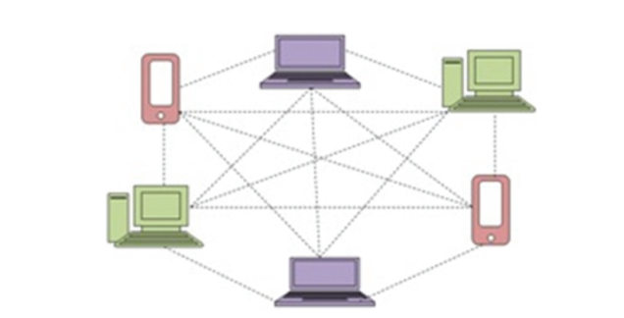

Private blockchain operates on access control, limiting participation to specific users and entities. This ensures reliability for transactions among third parties. Transactions are private, accessible only to involved entities. Examples include Linux Foundation and Hyperledger Fabric, commonly used in database management and auditing. Its primary applications are internal, maintaining data privacy and security, adhering to government regulations." The main advantages of private blockchain are data redundancies, easier data-handling, transaction cost and extra automated compliance functionalities."[]. The structure of private blockchain is shown in Figure.

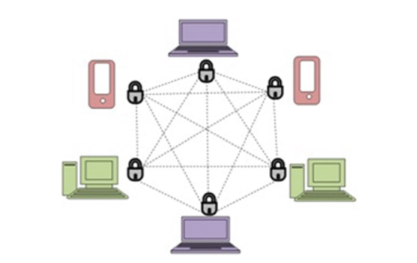

Consortium blockchain: "Consortium blockchain is an amalgamation of public and private blockchains. Private blockchain is applicable for enterprise solutions to preserve business data. The consortium blockchain is considered as a semi-private blockchain with a restricted user group but available across various organizations. In other words, this type of blockchain can be utilized if organizations are ready to share the blockchain, but restrict data access to them, and retain it secure from public access."[] Thus, it possesses the features of both public and private blockchains. Consortium blockchain is a cross-discipline and cross-company solution provider with the support of many blockchain platforms. A blockchain consortium of concurring companies can leverage information to advance workflows, accountability and transparency. The structure of Consortium blockchain is shown in Figure.

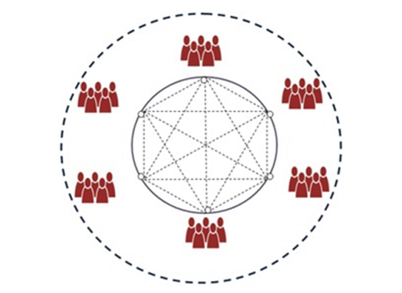

|  |  |  |  |
| --- | --- | --- | --- |
| Feature | Public Blockchain | Private Blockchain | Consortium blockchain |
| Accessibility | Open to anyone who wants to participate and view transactions | Restricted access, typically limited to approved participants | Restricted access, available to approved participants from multiple organizations |
| Participation Control | Decentralized, anyone can participate in transaction validation | Centralized, access controlled by designated entities | Semi-decentralized, control shared among participating organizations |
| Transparency | High transparency, all transactions are visible to all participants | Limited transparency, transactions may only be visible to authorized parties | Moderate transparency, transactions visible to approved participants across organizations |
| Data Privacy | Low data privacy, all transaction data is publicly accessible | High data privacy, transaction data is only visible to authorized parties | Moderate data privacy, data access restricted to approved participants |
| Security | Relies on consensus mechanisms to secure the network | Relies on access control and encryption for security | Relies on access control, encryption, and collaboration for security |
| Speed and Scalability | Slower transaction speeds and lower scalability due to open participation | Faster transaction speeds and higher scalability due to controlled participation | Moderate transaction speeds and scalability depending on consortium size |
| Use Cases | Ideal for cryptocurrencies and public applications where transparency is key | Suitable for enterprise solutions requiring data privacy and control | Suitable for collaborative projects across multiple organizations requiring shared data access and control |

## **Blockchain Platforms**

### **Ethereum Platform**

"Ethereum is a blockchain with a computer embedded in it. It is the foundation for building apps and organizations in a decentralized, permissionless, censorship-resistant way.” []

Ethereum is a public network that requires users to make payments in the form of Ether (ETH) to access its computational resources.

“Ether (ETH) is the native cryptocurrency of Ethereum. The purpose of ETH is to allow for a market for computation. Such a market provides an economic incentive for participants to verify and execute transaction requests and provide computational resources to the network.” []

Ether can be exchanged between users, used for trading, and utilized by developers on the Ethereum blockchain. Ethereum offers advantages such as decentralization, rapid deployment, permissioned network options, network size, private transaction capabilities, scalability, performance, transaction finality, tokenization of assets, and interoperability. However, there are also disadvantages, including the complexity of learning Solidity, scaling issues, and the risks associated with investing in Ethereum due to volatility and fluctuating fees. Ethereum uses programming languages like Solidity, LLL, Serpent, Vyper, Bamboo, and others. It can be both public and private, with applications built on the Ethereum Mainnet or private blockchains based on Ethereum technology. Data mining in Ethereum involves creating and adding blocks of transactions to the blockchain through the Proof-of-Work consensus mechanism, securing the network.

### **IBM Blockchain Platform**

“The IBM Blockchain Platform for IBM Cloud is the next generation of IBM Blockchain Platform offerings, which gives you total control over deployments, certificates, and private keys. It includes the new IBM Blockchain Platform console, a user interface that can simplify and accelerate the process of deploying components into a Kubernetes cluster on IBM Cloud managed and controlled by you. For more information about deploying a Kubernetes cluster on IBM Cloud.” []

IBM Blockchain is a robust platform developed by IBM to help businesses build and manage blockchain networks for various applications. It offers several advantages such as security, transparency, efficiency, traceability, and scalability. However, there are also challenges associated with its implementation, including complexity, regulatory uncertainty, integration issues, and governance concerns.

“Smart contracts on IBM Blockchain can be written in languages like Solidity, JavaScript, Go, and Java, catering to different development preferences and requirements.” []

The platform supports both public and private network configurations, with transaction costs varying depending on factors like network congestion and configuration.

While IBM Blockchain provides tools and frameworks for developing decentralized applications (dApps), the need for data mining within these applications depends on their specific functionalities and requirements. Overall, IBM Blockchain offers a robust foundation for building secure and scalable blockchain solutions, but businesses should carefully consider their needs and challenges before adopting the platform.

### **Hyperledger Platform**

“Hyperledger Fabric is an enterprise-grade permissioned blockchain platform that offers advantages such as a permissioned network structure, modular architecture, high performance, privacy features, and robust identity management capabilities.” []

“Fabric is the first distributed ledger platform to support smart contracts authored in general-purpose programming languages such as Java, Go, and Node.js, rather than constrained domain-specific languages (DSL). This means that most enterprises already have the skill set needed to develop smart contracts, and no additional training to learn a new language or DSL is needed.” []

It's typically deployed as a private network, though certain data or services can be made public if needed. Transaction costs can vary based on network configuration, and dApps built on Fabric do not require data mining for consensus. Overall, Hyperledger Fabric provides a flexible and customizable solution for organizations looking to build secure and scalable blockchain applications.

### **Hydrachain Platform**

“In a joint venture of the Ethereum project and Brainbot technologies, Hydrachain is an open-source blockchain platform to support and create private/permission Blockchain networks.” []

It serves as a flexible framework for building decentralized applications (dApps) and private blockchains. While specific details about HydraChain's features, advantages, and disadvantages may vary, it likely inherits some of the benefits associated with Ethereum, such as decentralization and support for smart contracts written in Solidity. Developers can deploy applications on both public and private networks, with transaction costs varying based on factors like network congestion and gas fees. Whether dApps built on HydraChain require data mining depends on their specific functionalities. Overall, HydraChain provides developers with a platform to create decentralized solutions while benefiting from the expertise of the Ethereum team.

### **R3 Corda Platform**

“R3 Corda is an enterprise level blockchain technology platform, was founded in 2014 by David E Rutter. It offers to deploy interoperable blockchain networks that interact in rigid privacy and requires two types of consensus, validity consensus and uniqueness consensus, for a transaction to get indexed inside a block.” []

It is an open-source blockchain platform designed specifically for the financial services industry. It was developed by R3, a company focused on creating interactive solutions for businesses using blockchain technology. Corda aims to address the specific needs and challenges faced by financial institutions by providing a secure and efficient platform for conducting transactions. Unlike traditional blockchain networks, Corda's architecture is designed to ensure privacy and confidentiality of transaction data, making it suitable for sensitive financial agreements. The platform utilizes a unique consensus mechanism called "Pluggable Consensus" that allows participants to select the consensus algorithm that best fits their needs. This flexibility enables Corda to be adaptable to various regulatory requirements and business preferences. Corda also offers "smart contract" functionality, known as "CorDapps," which are applications running on the network that can automate and enforce the terms of agreements without the need for intermediaries. This feature streamlines processes and increases efficiency in complex financial transactions. Furthermore, Corda emphasizes interoperability and connectivity, allowing different businesses or consortia to easily connect and transact with each other. This makes it easier for financial institutions to collaborate and share information securely within the platform. Overall, R3 Corda provides a robust, secure, and scalable blockchain solution tailored for the unique requirements of the financial services industry. Its focus on privacy, flexibility, and interoperability makes it an attractive choice for organizations seeking to leverage blockchain technology in their operations.

### **Multichain Platform**

“Multichain blockchain platform facilitates business houses and organizations to build and deploy private blockchain applications with speed and is peculiar for financial transactions only. While in other blockchain platforms, the design parameters are fixed but in Multichain blockchain platform, a single file params.dat holds the critical parameters which can be tweaked to suit the organizational requirements, and parameters like block incentive and transaction fees are null by default.” []

It is also a versatile blockchain platform that allows organizations to create and deploy their own customized blockchain networks. Its advantages include customization, privacy, scalability, interoperability, and cost-effectiveness. However, there are also concerns such as centralization, complexity, and limited decentralization. Smart contracts on Multichain can be written in various programming languages, and it supports the creation of both public and private blockchain networks. Transaction costs may vary, and data mining for dApps built on Multichain depends on the specific requirements of the application. Overall, Multichain offers a flexible solution for implementing blockchain technology tailored to the needs of businesses and organizations.

### **BigchainDB Platform**

“It has some database characteristics and some blockchain properties, including decentralization, immutability and native support for assets.

At a high level, one can communicate with a BigchainDB network (set of nodes) using the BigchainDB HTTP API, or a wrapper for that API, such as the BigchainDB Python Driver. Each BigchainDB node runs BigchainDB Server and various other software.” []

BigchainDB is an open-source, decentralized database system that combines the benefits of distributed databases and traditional blockchains. It provides decentralization, immutability, and scalability. While advantageous for various applications, it comes with complexities in implementation, potential storage costs, and a learning curve. BigchainDB supports multiple programming languages, and can be operated publicly or privately. Overall, it offers a flexible and versatile platform with considerations for both advantages and challenges.

### **Openchain Platform**

“Openchain is an open-source distributed ledger technology designed for secure and scalable management of digital assets, is based on partitioned consensus wherein different sets of the data take part in different consensus protocols” []

It is a private blockchain with advantages like scalability, customization, and interoperability. The platform primarily uses programming languages such as C#, ASP.NET Core, JavaScript/TypeScript, and SQL.

Openchain is free and open source, the need for mining in Openchain depends on the organization's use case and goals, with potential applications in transaction analysis, smart contract monitoring, audit, security analysis, and business intelligence

### **Quorum Blockchain Platform**

“Quorum is a private/permissioned blockchain based on the official Go implementation of the Ethereum protocol2. Quorum uses a ‘raft-based’ consensus algorithm (a consensus model for faster blocktimes, transaction finality and on-demand block creation), and achieves Data Privacy through the introduction of a new “private” transaction type. One of the design goals of Quorum is to reuse as much existing technology as possible, minimizing the changes required to go-ethereum in order to reduce the effort required to keep in sync with future versions of the public Ethereum code base, much of the logic responsible for the additional privacy functionality resides in a layer that sits atop the standard Ethereum protocol layer” []

Compared to public blockchains. Smart contracts on Quorum are typically written in Solidity, and it can be deployed as either a private or consortium network. Transaction fees can vary, and dApps built on Quorum may not require traditional data mining but may still involve data analysis for various purposes. Overall, Quorum presents a viable option for enterprise blockchain solutions, balancing benefits and challenges based on specific use cases and requirements.

### **EOS Blockchain Platform**

“The EOSIO blockchain platform is the next-generation, open-source platform with industry-leading transaction speed and a flexible utility. As a blockchain platform, EOSIO is designed for enterprise-grade use cases and built for both public and private blockchain deployments. EOSIO is customizable to suit a wide range of business needs across industries with role-based permissions system and secure application transactions processing.” []

EOS is a public blockchain platform known for its scalability, flexible governance model, and free transaction model for users. It allows for the development and deployment of decentralized applications (dApps) using smart contracts written in EOSIO C++ and other supported languages. While it offers advantages such as high throughput and easy upgrades, it also faces criticism for potential centralization concerns and complexity in development. Overall, EOS provides a platform for developers to build and deploy dApps with varying resource requirements, leveraging its unique features and governance structure.

### **Other Blockchain Platforms**

There are other Blockchain platforms like:

1. Bitcoin
2. Binance Smart Chain
3. Cardano
4. Solana
5. Polkadot
6. Avalanche
7. Tezos
8. NEO

## **Blockchain in Healthcare**

Blockchain technology has emerged as a promising solution to address various challenges in the healthcare industry. By leveraging its unique features such as enhanced security, improved interoperability, efficient data management, and patient privacy, blockchain offers transformative potential to revolutionize healthcare systems worldwide. Blockchain technology was able to solve several problems that existed I paper-based systems as Securing Health Data Privacy and security are paramount in healthcare, as patient data is sensitive and highly valuable. Blockchain employs cryptographic techniques and consensus mechanisms to ensure the integrity, confidentiality, and immutability of health data. Each transaction recorded on the blockchain is cryptographically linked to previous transactions, making it virtually impossible to alter or delete data retroactively. Moreover, access controls and permissioned blockchain networks enable granular control over who can view, edit, and share sensitive health information, reducing the risk of data breaches and unauthorized access .also Reducing Administrative Burden and Costs: Healthcare administration is often plagued by inefficiencies, paperwork, and administrative overheads, which contribute to high healthcare costs. Blockchain technology has the potential to streamline administrative processes, such as claims processing, billing, and revenue cycle management, by automating tasks, reducing intermediaries, and eliminating redundant paperwork. Smart contracts executed on the blockchain can automate payment settlements, enforce contractual agreements, and facilitate real-time transactions, resulting in cost savings, faster processing times, and improved accuracy in healthcare administration. These Solution contributed to use Blockchain in Electronic Health Records (EHRs)

Where it can facilitate the secure exchange of electronic health records (EHRs) among healthcare providers while ensuring patient privacy and data integrity. By storing encrypted patient data on a decentralized ledger, blockchain enables seamless access to comprehensive patient information across different healthcare organizations. This interoperability streamlines patient care delivery, reduces administrative overhead, and enhances healthcare outcomes. Therefore, the Electronic Health Record has contributed to:

* **Providing Digital Health Identity:** by facilitate the creation of a unique digital health identity for each patient. This digital health identity includes personal healthcare information such as medical history, prescribed medications, and medical tests, allowing patients to grant easy and secure access to caregivers.
* **Combating Medical Fraud:** by combat medical fraud by securely recording all medical information in a tamper-proof manner. Doctors, pharmacists, and healthcare facilities can verify the accuracy of information and prescriptions when needed, reducing the risk of medical data forgery and improper treatments.
* **Promoting Medical Research and Innovation:** By providing access to reliable and secure health data, researchers and medical institutions can use blockchain technology to accelerate research and development in the field of medicine and health. Data can be exchanged between different parties securely and effectively, promoting collaboration and innovation in healthcare.

## **AI**

“AI, a use of man-made brainpower, centers around creating computer programs that can get to information and learn to take decisions alone. It gives systems the capacity to learn without being unequivocally programmed. Its essential objective is to build strong algorithms which can get input information and utilize statistical examination for predicting and error-free outputs.” []

The roots of AI can be traced back to the mid-20th century when pioneers like Alan Turing and John McCarthy laid the groundwork for the field. Turing's concept of a "universal machine" and McCarthy's coining of the term "artificial intelligence" set the stage for decades of exploration and innovation. Early AI systems focused on symbolic reasoning and rule-based approaches, culminating in expert systems that could emulate human expertise in specific domains.

Over time, AI has evolved significantly, driven by advancements in computing power, data availability, and algorithmic sophistication. Key milestones include the development of neural networks in the 1950s, the resurgence of deep learning in the 21st century, and breakthroughs in areas such as natural language processing (NLP), computer vision, and reinforcement learning. These advancements have propelled AI from a theoretical concept to practical applications with real-world impact.

At its core, AI revolves around several fundamental concepts:

1. **Machine Learning (ML):** “Machine learning is a method of data analysis that automates analytical model building. Here the systems can learn from data, identify patterns and make decisions with minimal human interference. ML is an application of artificial intelligence that provides systems the ability to automatically learn and improve without being clearly programmed. It focuses on the development of computer programs that can access data and use them in learning. The process of learning begins with observations, like direct experience, or instructions, in order to find patterns in data and make better decisions for the future” []

ML algorithms enable systems to learn from data and improve performance over time without being explicitly programmed. Supervised learning, unsupervised learning, and reinforcement learning are common paradigms within ML.

1. **Deep Learning:** “Deep learning is a branch of ML, uses non-linear algorithms to enhance the performance and artificial neural networks with multiple layers to extract hierarchical representations of data.” []

It has driven significant breakthroughs in tasks such as image recognition, speech recognition, and natural language understanding.

1. **Natural Language Processing (NLP):** NLP focuses on enabling computers to understand, interpret, and generate human language. Applications range from chatbots and virtual assistants to language translation and sentiment analysis.
2. **Computer Vision:** Computer vision involves teaching computers to interpret and understand the visual world, enabling tasks such as object recognition, image classification, and autonomous driving.
3. **Reinforcement Learning:** Reinforcement learning is a branch of ML concerned with training agents to make sequential decisions in an environment to maximize cumulative rewards. It has applications in robotics, game playing, and autonomous systems.

AI has permeated various sectors, transforming industries and driving innovation in areas such as:

* Healthcare: AI is revolutionizing medical diagnosis, drug discovery, personalized treatment plans, and patient care management.
* Finance: AI algorithms are used for fraud detection, algorithmic trading, risk assessment, and customer service automation in the financial sector.
* Transportation: Autonomous vehicles powered by AI are poised to reshape the transportation landscape, improving safety, efficiency, and accessibility.
* Manufacturing: AI-enabled automation, predictive maintenance, and quality control are enhancing productivity and optimizing manufacturing processes.
* Retail: AI-driven recommendation systems, demand forecasting, and inventory management are enhancing the customer experience and optimizing operations in retail.

## **Importance of AI in Healthcare**

“The sophistication and growth of healthcare data imply that AI is becoming rapidly implemented in the area. Payers and care providers, and life sciences companies are already employing various types of AI. The key classes of utilizations include determination and treatment proposals, quiet commitment and adherence, and regulatory activities. Throughout the healthcare sector, the effect of AI is changing treatment delivery through natural language processing and ML. As is the case for many sectors, these innovations are projected to continue to develop at a steady rate over the next few years. As AI discovers its way into everything from our cell phones to the flexibly chain, applications in medicinal services, its potential in healthcare services may involve activities that vary from easy to complex—everything from answering the phone to analyzing medical history and patterns and the monitoring of public health, developing medicinal medications and tools, interpreting radiology scans, creating clinical diagnosis and treatment decisions and even talking to patients.” []

In personalized Patient Care AI algorithms analyze patient data, including medical records, genomic information, and lifestyle factors, to generate personalized insights and treatment recommendations. This personalized approach enhances patient engagement, improves treatment adherence, and ultimately leads to better health outcomes.

In diagnostic Accuracy and Efficiency AI-powered diagnostic tools can analyze medical images, pathology slides, and clinical data with remarkable accuracy and speed. Machine learning algorithms trained on vast datasets enable early detection of diseases, reducing diagnostic errors, and facilitating timely interventions.

In remote Monitoring and Telemedicine AI enables remote monitoring of patient vital signs, medication adherence, and disease progression, allowing healthcare providers to deliver virtual care effectively. Telemedicine platforms equipped with AI-driven chatbots and virtual assistants offer round-the-clock support, triage services, and medical advice to patients, particularly in underserved or remote areas.

In healthcare Operations Optimization: AI optimizes healthcare operations by streamlining administrative tasks, resource allocation, and workflow management. Predictive analytics models forecast patient demand, optimize bed utilization, and schedule appointments efficiently, reducing waiting times and improving healthcare service delivery.

In drug Discovery and Development AI accelerates drug discovery and development processes by analyzing vast datasets, simulating biological processes, and identifying potential drug candidates. Machine learning algorithms predict drug-target interactions, optimize drug formulations, and expedite clinical trials, leading to the discovery of novel therapies for various diseases.

In Clinical Decision Support Systems AI-powered clinical decision support systems provide healthcare practitioners with evidence-based recommendations, treatment guidelines, and real-time alerts. These systems analyze patient data, medical literature, and clinical guidelines to assist clinicians in making informed decisions, reducing medical errors, and enhancing patient safety.

In healthcare Fraud Detection and Prevention AI algorithms detect anomalies, patterns, and inconsistencies in healthcare claims data to identify potential cases of fraud, waste, and abuse. Machine learning models analyze billing patterns, patient histories, and provider behavior to flag suspicious activities, mitigate financial losses, and protect the integrity of healthcare systems.

In continuous Learning and Improvement AI systems learn and adapt over time, continuously improving their performance and capabilities. Through iterative learning processes, feedback loops, and data-driven insights, AI fosters a culture of continuous improvement in e-healthcare, driving innovation, and advancing medical knowledge.

## **Importance of AI in Patients Record Management System**

“The integration of Artificial Intelligence (AI) in a Blockchain-based platform for patient records management represents a groundbreaking approach that addresses critical challenges in the healthcare industry. This convergence of technologies offers unique advantages, revolutionizing how patient data is managed, secured, and utilized.” []

First and foremost, AI algorithms can analyze vast amounts of patient data efficiently, extracting valuable insights to improve healthcare outcomes. By leveraging machine learning techniques, the platform can identify patterns, trends, and anomalies within patient records, aiding in diagnosis, treatment planning, and disease prevention.

Moreover, Blockchain technology ensures the integrity and immutability of patient records, protecting them from unauthorized access and tampering. AI-powered encryption mechanisms further enhance data security by identifying potential threats and implementing robust encryption protocols, safeguarding sensitive patient information against breaches and cyberattacks.

In interoperability and Accessibility AI algorithms facilitate interoperability between disparate healthcare systems, enabling seamless data exchange and collaboration among healthcare providers. Through natural language processing (NLP) and data standardization techniques, the platform can reconcile inconsistencies in patient records, ensuring data accuracy and accessibility across different healthcare environments.

Furthermore, AI-driven insights derived from patient records empower healthcare providers to deliver personalized and precision medicine approaches tailored to individual patient needs. By analyzing historical data, genetic information, and clinical variables, the platform can recommend optimal treatment plans, predict disease progression, and identify personalized interventions for better patient outcomes.

In the realm of Clinical Decision Support, AI algorithms embedded within the platform offer real-time clinical decision support to healthcare practitioners, assisting them in making evidence-based decisions at the point of care. From drug interactions and adverse event predictions to diagnostic assistance and treatment recommendations, AI augments clinician expertise, improving diagnostic accuracy and patient safety.

Moreover, AI-enabled predictive analytics optimize resource allocation within healthcare systems, reducing operational costs and improving efficiency. By forecasting patient demand, predicting readmissions, and identifying high-risk populations, the platform enables proactive resource allocation, ensuring that healthcare resources are allocated where they are needed most effectively.

Lastly, AI algorithms learn and adapt over time, continuously improving the performance and capabilities of the platform. Through feedback loops and iterative learning processes, the system evolves to address emerging healthcare challenges, incorporate new medical knowledge, and enhance decision-making accuracy, fostering a culture of continuous improvement and innovation in patient care.

## **Internet Technology**

The Internet is defined as an electronic communications network that connects the computer network, public network connecting millions of computers around the world. It consists of millions of governments, academic, commercial and small government networks. The Internet is at the same time a global broadcasting capability, an information dissemination mechanism and a medium for cooperation and interaction between individuals and their computers without regard to their geographical location, Today, the Internet has a great deal of data and services, and perhaps the most commonly used today is web pages and phone applications

## **Web Programing Languages**

Web development languages are programming languages used to create websites and web applications. There are several web development languages, each with its own syntax, features, and purpose. Some of these languages are for front-end programming, while others for backend programming. As illustrated in the following sections.

## **Single Page compared to Multi-Page Application**

SPA (Single Page Application) and MPA (Multi-Page Application) are two different approaches to building web applications.

An SPA is a web application that loads a single HTML page and dynamically updates the content of that page as the user interacts with the application. The content is usually loaded using JavaScript frameworks such as React, Angular, or Vue.

SPAs provide a smooth user experience because they do not require the whole page to reload every time the user performs an action, and they can provide real-time updates without requiring a refresh.

On the other hand, an MPA is a web application that consists of multiple HTML pages, where each page represents a different functionality or feature of the application.

When the user interacts with the application, the server loads a new page and sends it to the client. MPAs are the traditional way of building web applications, and they provide a simple and straightforward approach to web development.

Here are some of the key differences between SPA and MPA

**Table 2-2 key differences between SPA and MPA**

|  |  |  |
| --- | --- | --- |
| Characteristic | SPA | MPA |
| Speed and Performance | SPA is usually faster than an MPA as most resources like HTML + CSS + Scripts are only loaded once throughout the lifecycle of applications | MPA is usually slower than SPA as Every change request renders a new page from the server in the browser. |
| Development Time | Developing, testing, and launching a single-page web app takes a lot less time as there is no need to write code and design an interface for multiple pages | Building a multi-page web application takes longer than building a single page app. This is because each page in your web app will need separate code and a separate design. Depending on the number and complexity of features, the time might also affect the cost |
| Navigation | SPA does not directly support back and forth navigation and sharing links of a specific location to a site, for this developers need to use an API. | The multi-page web application supports traditional navigation, each page of an MPA has its own URL that users can copy and paste. The backward and forward buttons also work easily. |
| Scalability | To make a SPA scalable developer might need to write big chunks of code. | MPAs are infinitely scalable. |

## **Front-End Programing Languages**

Front-end programming languages are used by developers to create the user interface of websites and web applications. "The component of an app or website that users interact with is called Front End or Client Side of the application. It includes everything that users come across directly including images, buttons, text colors, graphs, tables, etc." [6].

Some of the most popular front-end languages include HTML, CSS, and JavaScript. HTML and CSS are not programming languages, but a markup and a style sheet language. JavaScript is a programming language and is fundamental for website development.

### **Hypertext Markup Language HTML**

"The Hypertext Markup Language (HTML) is the standard markup language for documents designed to be displayed in a web browser."[13].

HTML used for creation hypertext documents that are platform independent. HTML gives a web page its structure. It is used to organize, format, and display a web page's content (like text, images, videos). HTML also makes it easier to navigate through the internet through hyperlinks. It allows users to control text and visual elements layout and display.

### **Cascade Style Sheeting CSS**

CSS is a World Wide Web Consortium (W3C) standard for describing the appearance of HTML elements. CSS is used to define the presentation of HTML documents. With CSS, we can assign the page layout, font properties, colors, sizes, borders, backgrounds, and positioning elements on the page. It is a markup language like HTML, and the two are frequently used together. CSS enables the display to be adjusted for different types of devices, such as large and small screens or printers. CSS is independent from HTML and does a few things that HTML can’t, which makes it useful for scaling content across different platforms as laptops and mobiles.



### **JavaScript**

"JavaScript, often abbreviated JS, is a high-level programming language that is one of the core technologies of the World Wide Web, alongside HTML and CSS. Over 97% of websites use JavaScript on the client side for web page behavior, often incorporating third-party libraries. All major web browsers have a dedicated JavaScript engine to execute the code on users' devices." [7].

It is mainly used in web browsers to create more interactive pages. The main peculiarity of this language is that it’s supported by most web browsers. Furthermore, JavaScript is a multi-paradigm language with numerous applications, but its ability to handle object-oriented styles makes it a wonderful companion for Java when it comes to websites. It can handle nested and anonymous functions, as well as classes, with well-structured syntax. So, one can create interactive e-commerce stores that work on almost all web browsers using this coding tool. It also makes websites launch super-fast and provides the end users with enhanced user experience (UX). The web browser can naturally understand the language, like how a native English speaker can naturally understand English.

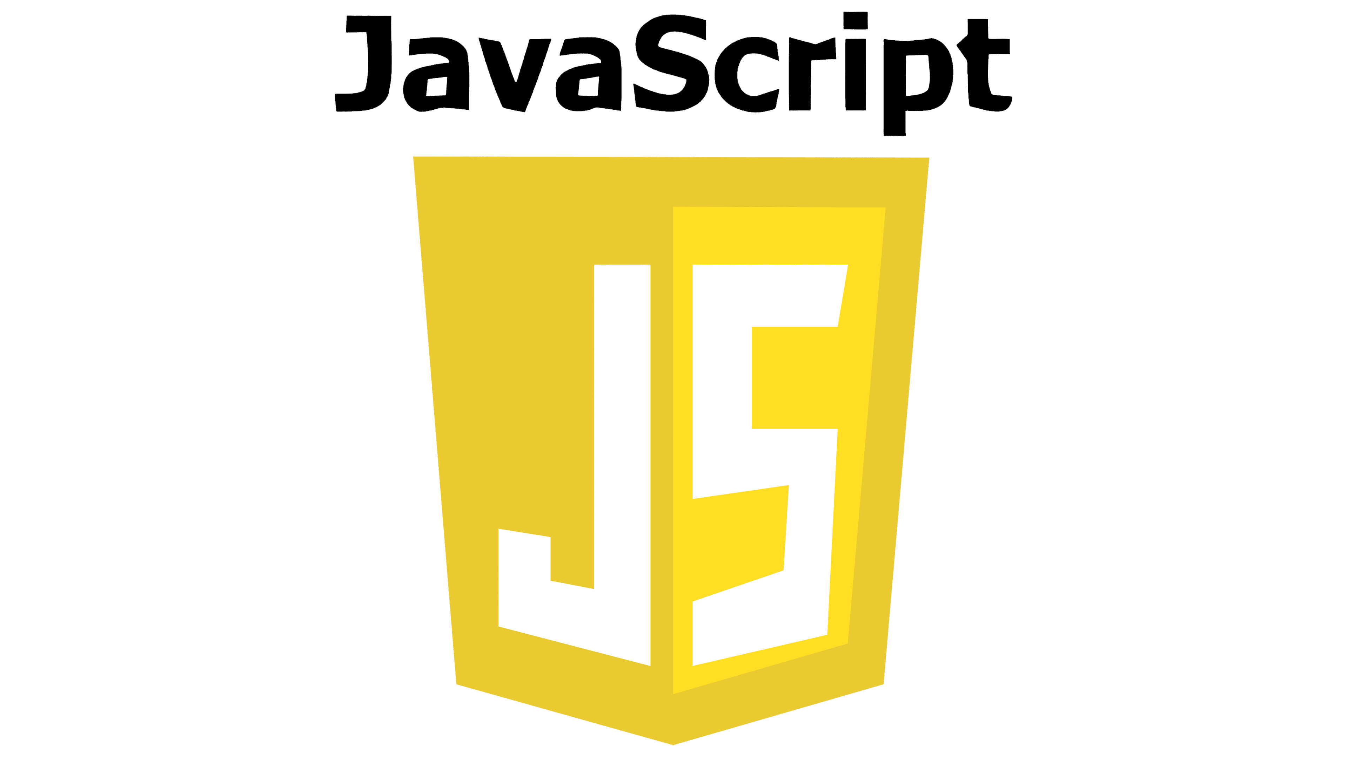

## **Frontend Frameworks and Libraries**

### **ReactJS**

ReactJS is a free and open-source front-end JavaScript library for building user interfaces based on UI components. It is developed by Meta. It can build web applications quickly and efficiently with significantly less code than you would with vanilla JavaScript. In React, you develop your applications by creating reusable components that you can think of as independent blocks. These components are individual pieces of a final interface, which, when assembled to form the application’s entire user interface.

"ReactJS is a JavaScript library for developing dynamic User Interfaces. It's developed and maintained by Facebook. React is an efficient, declarative and versatile JavaScript library for building user interfaces. Complex UIs can be composed from small, isolated and reusable pieces of code called “components”. ReactJS uses JSX to simplify writing HTML. JSX is a pre-processor that adds XML syntax to JavaScript " [6]. "As one of the top front-end frameworks React is an open-source tool powered by Facebook. It has been a developer’s delight owing to its salient features and user-friendliness. It is ideal for those who assume heavy traffic and need a robust platform for effective management. Its virtual DOM functionality and component-driven architecture offer great results"[21].

Key features of React:

• Reusability with high performance

• Great community support

• SEO and user-friendliness

• Good interaction between JavaScript and HTML

• Friendly syntax with ease of coding

### **Angular**

"Angular is an application-design framework and development platform for creating efficient and sophisticated single-page apps" [9]. "AngularJS is a JavaScript framework for developing dynamic single page web applications. It is developed and maintained by Google. It uses HTML as a template language and extends HTML's syntax to express the application's components clearly and concisely. AngularJS's dependency injection and data binding eliminate much of the code which might otherwise be needed to be written and it all happens within the browser, making it apt with any server technology " [6]. "AngularJS is one of the best front-end frameworks that is popular and simplistic and is based on TypeScript. It showcases a two-way data binding feature with real-time synchronization between view and model. As an open-source web and mobile application framework operated by Google, AngularJS has been contributory in accelerating the development and testing of apps with MVC and MVVM architectures" [8].

Key features in Angular:

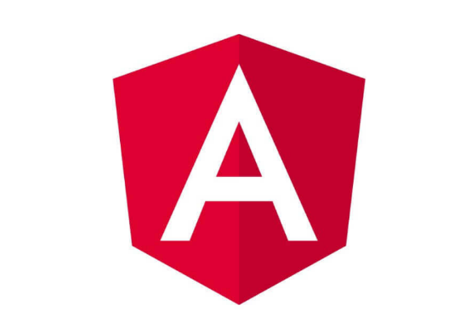• Reusability and agile approach

• Two-way data binding

• Plug-and-play components

• Fast and quality-based development

• Customized widget development

### **Vue.JS**

"Vue is a JavaScript framework for building user interfaces. It builds on top of standard HTML, CSS, and JavaScript and provides a declarative and component-based programming model that helps you efficiently develop user interfaces, be they simple or complex" [10]. "Vue is a progressive framework for building user interfaces and single-page web applications. Vue is designed to be an incrementally adaptable architecture that focuses on declarative rendering and component composition. VueJS is created and maintained by Evan You. Vue extends HTML with HTML attributes called "directives" [6]. "Vue.js is one of the most capable web front-end frameworks, to create collaborating user interfaces. It has been very straightforward to adapt and is lightweight in nature. It offers data-reactive components that have a simple and flexible API, two-way data binding, Virtual DOM, and component-based programming. It helps in the creation of dynamic web applications with ease and effectiveness" [8].

Key features in VueJS:

• Complicated dynamic apps and simple apps.

• Comprehensive documentation support.

• Simple to learn syntax

• Declarative rendering.

• Component level caching

## **Back-End Frameworks and Languages**

"Web creation at the Backend consists of countless activities. For example, protecting APIs (Application Programming Interfaces) against external attacks, authenticating users, enabling seamless interaction with databases, and handling user requests to collect and present the required information, etc. The backend frameworks enable all of these activities to developers simple and trouble-free".

### **NodeJS**

"Node.js is a cross-platform, open-source server environment that can run on Windows, Linux, Unix, macOS, and more. Node.js is a back-end JavaScript runtime environment, that runs on the V8 JavaScript Engine and executes JavaScript code outside a web browser " [12]. "Node.js is an asynchronous event-driven JavaScript runtime designed to build scalable network applications. It supports the handling of many connections concurrently. Call back is triggered for each connection and it sleeps if there is no work to be done. This behavior unlike too many other common concurrency models, in which operating system threads are used. Moreover, the users of Node.js need not worry about deadlocks, since there are no locks. Since almost no function performs an I/O in Node.js, the process never blocks. These properties make Node.js scalable. JavaScript language is used to write applications in Node.js and run with Node.js runtime environment. The package ecosystem of Node.js called npm (node package manager) has a large number of open-source libraries. Node.js uses Google Chrome’s super-fast highly optimized V8 execution engine in JIT (Just in Time) compilation fashion to execute JS code by transforming them into machine language and optimizes through complicated methods such as code in lining, copy emission, etc.".

### **Laravel**

Laravel is a free and open-source PHP web framework, created by Taylor Otwell in 2012 and intended for the development of web applications following the model–view–controller (MVC) architectural pattern. Laravel attempts to take the pain out of development by easing common tasks used in the majority of web projects, such as authentication, routing, sessions, and caching. "Laravel is a web application framework with expressive, elegant syntax. A web framework provides a structure and starting point for creating your application, allowing you to focus on creating something amazing while we sweat the details. Laravel strives to provide an amazing developer experience while providing powerful features such as thorough dependency injection, an expressive database abstraction layer, queues and scheduled jobs, unit and integration testing, and more. Whether you are new to PHP web frameworks or have years of experience, Laravel is a framework that can grow with you".

### **Django**

"Django is a web framework based on python programming language. It is ridiculously fast and was designed to help developers transform concept to application as quickly as possible. It takes care of much of the struggle of web application development thereby allowing developers to focus on writing actual business logic of the app without needing to reinvent the wheel. It is incredibly versatile. Django takes care of many necessary tasks of web development such as user authentication, site maps, content administration, RSS (Really Simple Syndication) feeds, etc. Famous web applications such as Instagram, Udemy, Mozilla and Pinterest use Django. Django follows a Model-View-Controller (MVC) architecture. The Model is the logical data structure that acts as a mediator between the website interface and the database. The View component contains the user interface logic. The controller is the main control component and acts as the middleman that binds the view and model together, meaning it enables the data passing from model to view. ".

### **Personal Home Page PHP**

"PHP Personal Home Page (PHP) is a general-purpose scripting language geared toward web development. It was originally created by Danish-Canadian programmer Rasmus Lerdorf in 1994. PHP originally stood for Personal Home Page, but it now stands for the recursive initialism PHP: Hypertext Preprocessor". It is an open source server-side scripting language and a powerful tool for creating dynamic and interactive Web sites. It does not concentrate on client-side or frontend duties. It manages data and server-side processes in the background with the aid of an interpreter. The most significant advantage of PHP is that it can be directly inserted in HTML. It's used to manage dynamic content, databases, and session monitoring. MySQL, PostgreSQL, Oracle, Sybase, Informix, and Microsoft SQL Server are just a few of the databases it supports. POP3, IMAP, and LDAP are just a few of the important protocols that PHP supports.

## **GitHub**



**“**GitHub is a web-based interface allowing real-time collaboration. It encourages teams to work together in developing code, building web pages and updating content.**”,** It offers developers so many features like:

**1. Distributed Version Control**

GitHub offers a distributed version control system (DVCS) powered by Git, which enables us to efficiently manage changes to our codebase. With Git, every developer has a local copy of the entire project history, allowing for seamless branching, merging, and tracking of changes.

**2. Collaboration**

GitHub provides a robust platform for collaboration among team members and external contributors. Its features such as pull requests, issues, and project boards facilitate communication, code review, and task management, thereby enhancing team productivity and fostering a collaborative environment.

**3. Community and Ecosystem**

GitHub boasts a vast community of developers and open-source projects. By hosting our project on GitHub, we tap into this vibrant ecosystem, making it easier for others to discover, contribute to, and provide feedback on our project. Additionally, GitHub's integration with various third-party services and tools further enriches our development workflow.

**4. Documentation and Insights**

GitHub offers comprehensive documentation features, including wikis and README files, enabling us to provide essential project information and guidelines for contributors. Moreover, GitHub's built-in analytics and insights help us track project activity, identify trends, and make data-driven decisions to drive the project forward.

**5. Continuous Integration and Deployment (CI/CD)**

Integrating GitHub with CI/CD pipelines allows us to automate the testing, building, and deployment processes, ensuring the reliability and stability of our software. GitHub Actions, in particular, provides powerful workflow automation capabilities, seamlessly integrated within our repository.

**6.Managing team access to an organization repository**

You can give a team access to a repository, remove a team's access to a repository, or change a team's permission level for a repository.

**7. Showcase or share your work**

**8. Track and manage changes on code over time.**

## **PostgreSQL**

PostgreSQL is an open-source relational database management system (RDBMS) known for its robustness, extensibility, and adherence to SQL standards. Originally developed at the University of California, Berkeley, PostgreSQL has evolved into a mature and feature-rich database solution widely used in various industries and applications.

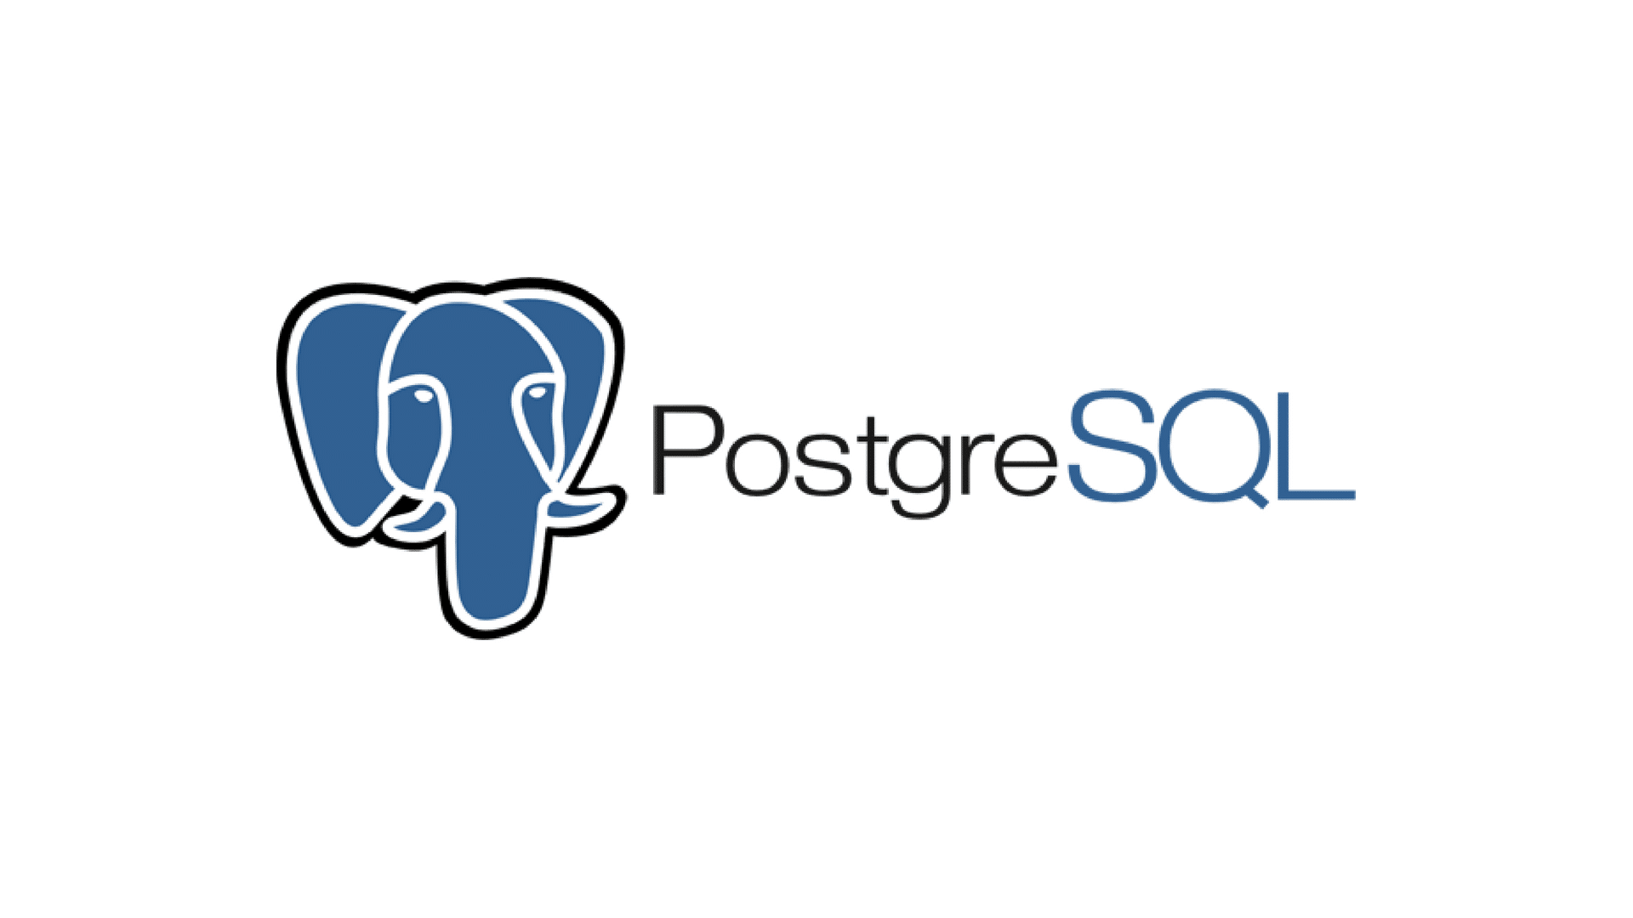

“PostgreSQL has earned a strong reputation for its proven architecture, reliability, data integrity, robust feature set, extensibility, and the dedication of the open source community behind the software to consistently deliver performant and innovative solutions. PostgreSQL runs on all major operating systems, has been ACID-compliant since 2001, and has powerful add-ons such as the popular PostGIS geospatial database extender. It is no surprise that PostgreSQL has become the open source relational database of choice for many people and organisations”.

Which offers so many advantages in our Blockchain based project Like:

1. **Relational Data Management**: PostgreSQL is a robust relational database management system (RDBMS) that allows you to efficiently store and manage structured data. While Hyperledger Fabric provides distributed ledger capabilities for immutable and transparent transaction recording, PostgreSQL complements it by offering a reliable storage solution for relational data associated with our blockchain transactions.
2. **Querying Flexibility**: PostgreSQL's powerful querying capabilities enable you to perform complex data retrieval operations. This is particularly useful when we need to analyze and extract insights from the data stored on our blockchain network.
3. **Scalability and Performance**: PostgreSQL is known for its scalability and performance optimizations. As our blockchain network grows and the volume of data increases, PostgreSQL can efficiently handle the load while maintaining high performance. With proper indexing and tuning, we can ensure that our database remains responsive even under heavy transactional workloads.
4. **Data Integrity and Security**: PostgreSQL offers robust features for ensuring data integrity and security. We can implement constraints, triggers, and data validation rules to enforce business logic and prevent invalid or unauthorized transactions. Additionally, PostgreSQL supports advanced security mechanisms such as role-based access control (RBAC), SSL encryption, and data encryption at rest, which help protect sensitive information stored in your database.
5. **Integration and Ecosystem**: PostgreSQL has a vibrant ecosystem with a wide range of tools, libraries, and extensions available. This allows us to easily integrate PostgreSQL with other components of our technology stack and leverage additional functionalities as needed. Whether it is geospatial analysis, full-text search, or compatibility with popular programming languages and frameworks, PostgreSQL offers numerous extensions and integrations to enhance the development experience.
6. **Community Support and Documentation**: PostgreSQL boasts an active community of developers and users who contribute to its ongoing development and provide support through forums, mailing lists, and online resources. This wealth of community-driven knowledge ensures that we can find solutions to any challenges we encounter while working with PostgreSQL in our Hyperledger Fabric project.

## **IPFS**

“IPFS is a peer-to-peer version controlled filesystem that synthesizes learnings from many previous successful systems. IPFS combines a distributed Hash table, an incentivized block exchange, and a self-certifying namespace. IPFS is a peer-to-peer hypermedia protocol to make the web faster, safer, and more open.

The InterPlanetary File System (IPFS) which is a peer-to-peer distributed file system, aims to replace HTTP and build a better web for all of us. IPFS seeks to connect all computing devices with the same system of files. IPFS thinks that HTTP fails to take advantage of dozens of brilliant file distribution techniques invented in the last fifteen years” []

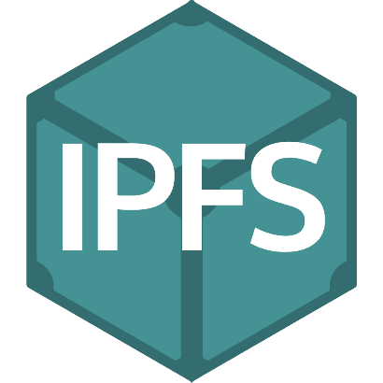

While Bitcoin blockchain has a standard block size of approximately 1 MB, and these contain around 1,500–1,900 transaction details being coordinated from one address to other. On the other hand, if we try to impose the same kind of architecture in healthcare, huge data sets envisaged in the healthcare domain would be a challenge to reckon. Huge data sets as being discussed in the domain of healthcare of the size in zettabytes would not be apt to be indexed in blocks. Even if we increase the block size to contain the healthcare data, it would have a snowball effect into the efficiency and transaction confirmation delays. Thus, there is a need such that the blocks contain the regular hashes of the transaction and data sets are stored in a decentralised manner. This decentralised storage can be coordinated with the aid of IPFS protocol. This integration offers numerous benefits like:

1. **Decentralized File Storage:** IPFS provides a decentralized file storage solution, allowing us to store and retrieve large files in a distributed manner. Unlike traditional centralized storage systems, IPFS distributes files across a network of nodes, ensuring redundancy and fault tolerance.
2. **Immutable File System:** IPFS employs content-addressed storage, where files are identified by their content rather than their location. This ensures immutability, as any change to a file results in a new content identifier (CID). This property aligns well with the principles of blockchain, where immutability is crucial for maintaining the integrity of data.
3. **Reduced Storage Costs:** By utilizing IPFS for file storage, we can potentially reduce storage costs compared to traditional centralized storage solutions. Since IPFS leverages peer-to-peer networking, users contribute storage and bandwidth resources, distributing the cost burden across the network.
4. **Enhanced Data Privacy:** IPFS allows us to encrypt files before storing them on the network, enhancing data privacy and security. This feature is particularly important for sensitive or confidential information stored on the blockchain.
5. **Efficient Content Distribution:** IPFS facilitates efficient content distribution by leveraging a distributed network of nodes. Files are cached locally, reducing latency and improving performance for users accessing the content.
6. **Immutable Off-Chain Data:** We utilize IPFS to store off-chain data, such as large documents or media files associated with transactions on the Hyperledger Fabric blockchain. This approach ensures that transaction data remains immutable on the blockchain while off-chain data can be efficiently stored and accessed through IPFS.
7. **Secure Document Management:** IPFS integration enhances document management capabilities within our application. Documents can be securely stored on IPFS, with their content addresses stored on the blockchain, providing a secure and tamper-resistant reference to the documents.
8. **Scalability and Performance:** By offloading file storage to IPFS, we improve the scalability and performance of our Hyperledger Fabric network. This separation of concerns allows the blockchain to focus on transaction processing, while IPFS handles large file storage and retrieval operations.
9. **Regulatory Compliance:** IPFS integration helps address regulatory compliance requirements by providing a secure and auditable solution for storing and managing documents associated with blockchain transactions. Compliance-related documents can be securely stored on IPFS, with their integrity guaranteed by blockchain immutability.
10. **Performance:** IPFS provides faster access to data by enabling it to be replicated to and retrieved from multiple locations, and allowing users to access data from the nearest location using content addressing instead of location-based addressing. In other words, because data can be addressed based on its contents, a node on the network can fetch that data from any other node in the network that has the data; thus, performance issues like latency are reduced.
11. **Link rot:** IPFS eliminates the problem of link rot by allowing data to be addressed by its content, rather than by its location. So, in other words, content in IPFS is still reachable regardless of its location, and does not depend on specific servers being available**.**
12. **Data sovereignty:** IPFS protects data sovereignty by enabling users to store and access data directly on a decentralized network of nodes, rather than centralized, third-party servers. This eliminates the need for intermediaries to control and manage data, giving users full control and ownership over their data.
13. **Local-first software:** IPFS benefits local-first software by providing a performant, decentralized, peer-to-peer data addressing, routing, and transfer protocol that prioritizes data storage and processing on individual devices. With IPFS, data can be stored, verified and processed locally, and then synchronized and shared with other IPFS nodes when a network connection is available.
14. **Vendor lock-in:** IPFS prevents vendor lock-in, as users have sovereignty over their data and infrastructure. This is enabled by content-addressing, which decouples the data from a single location or infrastructure provider. Unlike traditional cloud vendors, IPFS enables you to change data storage locations without changing things like APIs and data management. In addition, because IPFS is open-source, community-maintained and modular, users are not obligated to use a particular subsystem (described in How IPFS works). Instead, users can customize IPFS for their preferred technologies, needs and values.

## **Python**

Python is a high-level programming language known for its simplicity and readability. It was created by Guido van Rossum and first released in 1991. Python is versatile and can be used for various purposes, including web development, data analysis, artificial intelligence, scientific computing, automation, and more. It emphasizes code readability and has a large standard library, making it easy to learn and use for both beginners and experienced programmers.

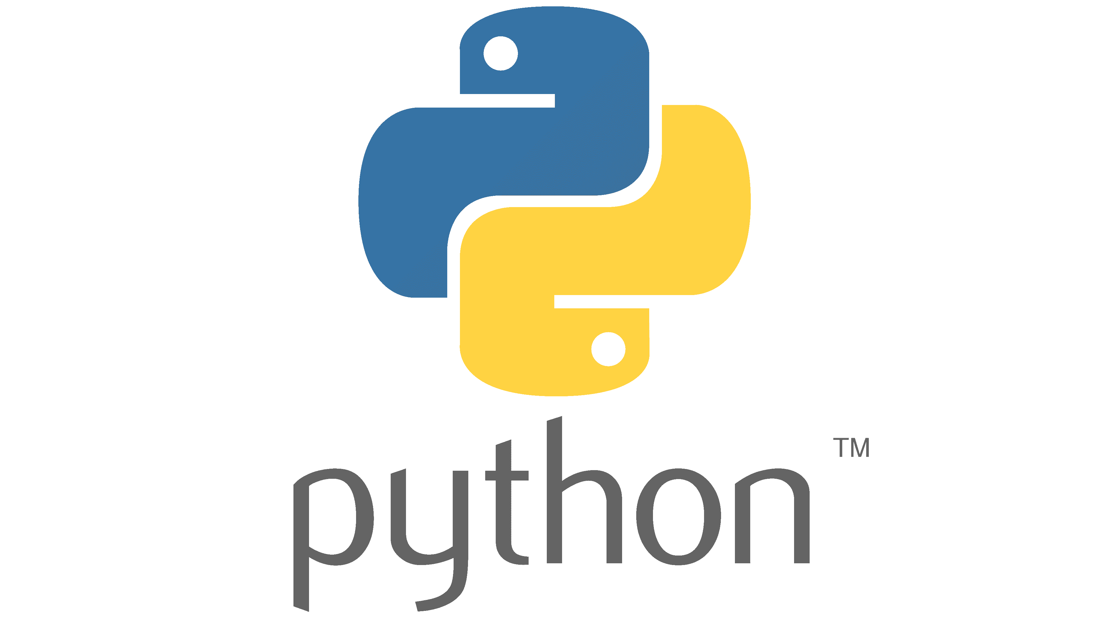

It plays a pivotal role in the development of our AI-Driven Blockchain Platform for Patients Records Management System. Its integration serves several fundamental purposes, enhancing the functionality, efficiency, and versatility of our system. it gives us:

1. **Robust Ecosystem for AI Development:** Python boasts a rich ecosystem of libraries and frameworks tailored for artificial intelligence and machine learning tasks. By leveraging Python, we tap into this extensive array of tools, such as TensorFlow, PyTorch, and scikit-learn, to facilitate the integration of AI functionalities into our platform seamlessly.
2. **Simplicity and Readability:** Python's syntax is renowned for its simplicity and readability, making it an ideal choice for development projects of varying complexities. This characteristic enhances the maintainability of our codebase, enabling smoother collaboration among developers and facilitating the onboarding of new team members.
3. **Efficiency in Prototyping and Iterative Development:** Python's dynamic nature and high-level abstractions expedite the prototyping phase of our development process. With Python, we can rapidly iterate through different AI algorithms, experiment with various approaches, and swiftly adapt to evolving requirements. This agility is particularly advantageous in the dynamic landscape of healthcare systems and regulatory frameworks.
4. **Integration with Blockchain Technology:** Python offers robust support for interfacing with external systems and technologies, including blockchain platforms. Leveraging Python libraries such as web3.py, we can seamlessly interact with blockchain networks, enabling secure and transparent management of patients' medical records. This integration enhances data integrity, privacy, and traceability within our platform.
5. **Community Support and Documentation:** Python benefits from a vibrant community of developers, researchers, and enthusiasts who actively contribute to its growth and evolution. The extensive documentation, tutorials, and community forums associated with Python ensure that our development team has access to ample resources for troubleshooting, learning, and innovation.

## **Visual Studio Code**

Visual studio code provides fast tools also have many package for many program language that needed to create this web

Application.

Also it provides many advantages such as ease of use, and the presence of great content to learn to use the program.



## **Smart Contracts**

Smart contracts are self-executing contracts with the terms of the agreement directly written into code. In the context of Project , smart contracts facilitate automated and secure execution of predefined business logic on the blockchain. This ensures transparency, immutability, and trust in the execution of transactions. In the development of Our Project , the decision to use Java as the programming language for writing smart contracts on the Hyperledger Fabric.

## **Conclusion**